Nottingham Trent University

School of Science and Technology

Sweet sensation, tackling obesity

by

Christopher Thomas Martin

in

2017

Project report in part fulfilment

of the requirements for the degree of

Bachelor of Science with Honours

in

Computer Science (Games Technology)

I hereby declare that I am the sole author of this report. I authorize the Nottingham Trent University to lend this report to other institutions or individuals for the purpose of scholarly research.

I also authorize the Nottingham Trent University to reproduce this report by photocopying or by other means, in total or in part, at the request of other institutions or individuals for the purpose of scholarly research.

Signature

Christopher Thomas Martin

# Abstract

Obesity continues to be a growing problem to world health, while many potential solutions to the problem have been put forward, the issue persists. Video games have been linked as causes of obesity, yet research has also shown, positive exercise habits can be gained through the use of video games. This paper presents a new approach designed around the idea of building positive habitual behaviour, in users that lack the motivation to take part in regular fitness activities. An application by the name Sweet Sensation built around this idea has been developed and documented in this report, tested against several metrics including with members of a targeted userbase, resulting in near completion of all pre-determined objectives of the project. The hope here is that through regular use of this application, in theory a user should start to develop beneficial habits relating to regular exercise, where initially the was none. This project also reveals several channels of further research which could generate new scientifically significant results.

# Acknowledgements

My sincerest thanks to my project supervisor Giovanna Martinez Arellano not only for the help and support offered during this project but for helping me through three more years of university, your honesty and friendship means a lot. Special thanks also go out to my housemates who have offered me unconditional support even when under the strain of their own final year, and finally I would like to express my appreciation to friends, family members and university staff who have helped me achieve all that I have accomplished during my time at Nottingham Trent University.

Contents

Abstract ii

Acknowledgements iii

List of Figures xi

List of Tables xii

Chapter 1 – Introduction 1

1.1 Project scope 2

1.2 Project Overview 3

1.2.1 Chapter 2: Context 3

1.2.2 Chapter 3: New Ideas 3

1.2.3 Chapter 4: Implementation 3

1.2.4 Chapter 5: Results 3

1.2.5 Chapter 6: Conclusions 3

Chapter 2 – Context 5

2.1 Introduction 5

2.2 Design Requirements for Technologies that Encourage Physical Activities (Consolvo et al., 2006) 5

2.3 Fish ‘n’ steps: Encouraging Physical Activity with an Interactive Computer Game (Lin et al., 2006) 7

2.4 Physiological and Perceptual Responses to Nintendo Wii Fit in Young and Older Adults (Mullins et al., 2017) 9

2.5 The health benefits of interactive video game exercise (Warburton et al., 2007) 11

2.6 Conclusion 12

Chapter 3 – New Ideas 13

3.1 Introduction 13

3.2 Observable gap 13

3.2.1 Scientific questions related to the observable gap 14

3.3 Abstract of new idea 14

3.4 Project aim and objectives 15

3.4.1 Project aim 15

3.4.2 Project objectives 15

3.5 Project test plan 17

3.5.1 Tests 17

3.6 Methodology choice 18

3.6.1 Gantt chart 21

3.7 Investigation 23

3.7.1 Total downloads since release 23

3.7.2 Popularity with user demographic 23

3.7.3 Revenue generated 23

3.7.4 General review 24

3.7.5 Conclusion 24

3.7.6 Candy Crush Saga results 25

Chapter 4 – Implementation 27

4.1 Introduction 27

4.2 Lean UX project methodology 27

4.3 Development 29

4.3.1 Overview 29

4.3.2 Development tools 31

4.3.3 Key features 36

Chapter 5 – Results 48

5.1 Introduction 48

5.2 User Testing 48

5.2.1 User testing overview 49

5.2.2 User testing results 49

5.2.3 User testing task time distribution 52

5.2.4 SUS test results 53

5.2.5 User testing summary 54

5.3 Project objectives 55

5.4 Test plan 56

5.4.1 Google Fit API integration 57

5.4.2 Node.js webserver 58

Unity game client 58

5.4.3 Summary 59

5.5 Lean UX hypotheses 59

5.5.1 Hypothesis One 60

5.5.2 Hypothesis Two 61

Chapter 6 – Conclusion 62

6.1 Project summary 62

6.1.1 PESL issues 64

6.2 Future work 65

6.2.1 Scientific questions 65

6.2.2 Application release 66

References 67

Bibliography 72

Appendix A – Building and running the application 77

Rebuilding the source code 77

Running the source code 78

Key files 78

Appendix B – Top five games investigation 79

Candy Crush Saga 79

Subway Surfers 80

Pou 80

Temple run 2 81

Hill Climb Racing 82

Appendix C – Lean UX implementation 83

Problem statement 83

Assumptions 83

Assumptions questionnaire 83

Prioritisation matrix 87

Prioritised list of assumptions 88

Hypotheses 89

Hypothesis one 89

Hypothesis two 89

Appendix D – Paper prototype design 90

Appendix E – Usability plan template 94

Overview 95

Executive Summary 95

Methodology 96

Participants 96

Procedure 97

Roles 97

Trainer 98

Facilitator 98

Data Logger 98

Test Participants 98

Ethics 98

Usability Tasks 98

Usability Metrics 99

Scenario Completion 99

Critical Errors 99

Non-critical Errors 100

Subjective Evaluations 100

Scenario Completion Time (time on task) 101

Usability Goals 101

Completion Rate 101

Error-free rate 101

Time on Task (TOT) 101

Subjective Measures 102

Problem Severity 102

Impact 102

Frequency 102

Problem Severity Classification 102

Reporting Results 103

Appendix F – Usability testing consent questionnaires 103

Appendix G – System Usability Scale results 111

Appendix H – Full test plan results 114

Appendix I – Project Planning Document 115

Introduction 115

Aims and objectives 116

Project aim 116

Project objectives 116

Milestones, main tasks and deliverables 118

Project scope 118

Out of scope 118

Milestones & Main tasks 119

Project Milestones 119

Project main tasks 119

Sources of information, resources required 119

Resources 119

Sources of information 120

Project risks 121

Professional, social, ethical and legal issues 122

Professional 122

Social 122

Ethical 122

Legal 122

Gantt chart 123

# List of Figures

Figure 1- Paper design of application log in screen 19

Figure 2 – Gantt chart in table form 21

[Figure 3 – Gantt chart 22](https://d.docs.live.net/826ff50a3d3cac88/FYP/Report/ReportTemplate.docx#_Toc481041959)

[Figure 4 – Candy crush application icon 25](https://d.docs.live.net/826ff50a3d3cac88/FYP/Report/ReportTemplate.docx#_Toc481041960)

Figure 5 – High level system overview 31

Figure 6 – Paper prototype example A: Application log in screen 36

Figure 7 – Paper prototype example B: Level start screen 37

Figure 8 – Screen capture of running application 38

Figure 9 – Screen capture of application rewards activity 39

Figure 10 – Screen capture of application store activity 40

Figure 11 – Screen capture of Highscore activity 41

[Figure 12 – High level data flow diagram between client and server 43](https://d.docs.live.net/826ff50a3d3cac88/FYP/Report/ReportTemplate.docx#_Toc481041968)

[Figure 13 – User level failure system process 44](https://d.docs.live.net/826ff50a3d3cac88/FYP/Report/ReportTemplate.docx#_Toc481041969)

Figure 14 - SUS score to adjective rating comparision of 959 tests (Bangor, Kortum, and Miller, 2009) 54

# List of Tables

Table 1 – Mobile phone operating system market share 32

Table 2 – Usability testing summary table 50

Table 3 – User testing time distribution per user for each task 52

Table 4 – System Usability Scale results 53

Table 5 – Project objective test results 55

Table 6 – Google Fit API test results 57

Table 7 – Webserver test results 58

Table 8 – Game client test results 59

# Chapter 1 – Introduction

The UK has one of the highest levels of obesity in Europe, Europe’s average level of obesity sits at 21.4% with the UK averaging at 24.9% (The State of Food and Agriculture 92-93). Obesity levels have more than trebled in the last thirty years with estimates that more than half of the population could be obese by the year 2050 (Stephenson, 2013). The cause of this dramatic increase in people’s weight has been linked to an increasingly sedentary lifestyle as well as greater consumption of energy dense foods (Purnel et al, 1999).

Behavioural changes have been suggested as a method of reversing this downward trend in health, however an individual’s behaviour is typically the result of multiple influences, often making it resistant to change (Thompson et al., 2008). Subsequently to change an individual’s behaviour small changes should be made to the mediation variables which indirectly contribute and influence an individual’s behaviour (Preacher and Hayes, 2008).

Despite video games being linked as a cause of obesity (Vandewater, Shim and Caplovitz, 2004), Pate (2008) argues that, in a contemporary society where “electronic entertainment is not going to go away”. The use of video games has been suggested as a way to positively influence a user’s health, (Lin et al., 2006) due to the high level of immersion and interaction they offer. With video game usage on the rise (2016 Global Games Market Report, 2016) this method of behavioural change becomes an increasingly viable option.

As such the following report details the creation of an application that takes a novel approach to the problem of obesity. This is based around the idea of appealing to users who have no real motivation to regularly exercise, in the hopes of eventually producing behavioural change.

## 1.1 Project scope

The scope of this project was to create a mobile game that makes use of fitness data gathered from health tracking hardware and software located on the user’s mobile device to grant a benefit to the users in game experience. The application will be designed operate in a multiplayer setting, with actions of the player having some impact on other users.

Crucially the application is designed to be usable without the need to interact with the fitness related functionality, the goal of this is to make the application more accessible to users who have no motivation to take part in fitness based activities. Once invested in the application it is then hoped the user will make use of these fitness based elements to improve their player experience, resulting in the growth of positive habitual behaviour, which otherwise would not have been developed.

## 1.2 Project Overview

### 1.2.1 Chapter 2: Context

Chapter Two documents the research undertaken in this project within the scientific fields of video games and fitness. Several peer reviewed papers are discussed and their findings critiqued, the goal of this chapter was to identify a gap in the current research available to the scientific community.

### 1.2.2 Chapter 3: New Ideas

New ideas acts upon the findings from Chapter Two, having performed sufficient research into the topic area, Chapter Three documents the project ideation, the process of setting a project aim and its objectives as well as methodology choice, test plan creation and an investigation into a style and theme for the application developed.

### 1.2.3 Chapter 4: Implementation

Chapter Four describes in detail the development of the application presented in this report, the chapter starts with an explanation on the implementation of the project methodology, this is followed by a report on the development of the application which contains a system overview, justification for the tools used during development and an explanation of the key features of the application.

### 1.2.4 Chapter 5: Results

The results chapter compares the developed solution described in the previous chapter with several metrics to test whether the projects aims had been met as determined in Chapter Three.

### 1.2.5 Chapter 6: Conclusions

The closing chapter in this report provides a summary of the results from the previous chapter, building upon whether the projects aim has been met, Chapter Six looks at the solution in the wider context of the scientific community. The Professional, Social, Ethical and Legal issues of the project are also considered in this chapter, finally looking ahead, the concluding section in this chapter explores the future work made possible due to this project.

# Chapter 2 – Context

## 2.1 Introduction

The following chapter presents a critical review of the State-of-the-Art currently available within the combined fields of video gaming and exercise. The aim of this review was to identify an area where a gap was present in the State-of-the-Art of the scientific community, which would then be developed upon eventually resulting in the solution presented in this report.

## 2.2 Design Requirements for Technologies that Encourage Physical Activities (Consolvo et al., 2006)

A study conducted in 2006 designed to test various design principles for creating applications that would encourage opportunistic physical activities by users. Participants were split into three groups based on the users’ friendships, each participant was grouped with at least two members who they would consider friends, the justification for this was to allow for the testing of the impact social interaction may have on the results. Three phone based applications were designed for the study;

* A baseline application in order to collect enough data to set a fitness goal
* A personal application that one group would use throughout the study, it contained all the functionality of the baseline version as well as;

functionality to view the daily goal as well as progress towards that goal

recognition for meeting daily goals

view the user’s average daily steps based on the count of the last 7 days

add optional comments

functionality to view previous comments

* A social application used by the remaining two groups during the main study, that had all the features of the personal version as well as functionality to;

Send step counts and comments to any/ all members of their group

see the progress other group members had made toward their fitness goal

request a step count from other members of their group

Using a pedometer, the user’s step totals would be recorded each day, at any point in a day a user could access the phone application and record their data.

Results from the study concluded that users who participated in the social testing group were more likely to achieve their fitness goal (t=2.60, p<0.05), and all users who took part in some way improved upon their daily average step total with results ranging from 5% to 61%, the authors of the study however admit that the testing period of the experiment was low so these results may be misleading. In addition to the quantitative results of the experiment four design principles have been put forward to future developers of systems designed to encourage exercise, these are;

Give users proper credit for their activity

Provide personal awareness of activity level

Support social influence

Consider the practical constraints of user’ lifestyle

The design principles put forward in this paper are all well-conceived and will be used during the development of this project. The report also talks about the decision process behind setting the step goal for the users, instead of using a one size fits all approach (i.e. each user has a goal of 10,000 steps per day) the decision was made to use the baseline application to generate a fitness goal based off the first week’s results. Feedback from participants was mixed, most were unhappy with the goal the baseline application had set for them due to the way it had been calculated, others felt unhappy that they had different goals to their friends and wanted something standardised to allow for more competition. Another consideration discussed within the paper is around the choice to use active data tracking, this being the physical logging of steps from participants, compared to automatic tracking which would automatically log steps. No definitive answer is given to which is better as active input provides the user with constant feedback which is a key to goal achievability, whilst the other allows for ease of use which is a key consideration in software design.

Finally, whist the testing time of the application was low the results it produced do suggest that social engagement can play a large role in user participation, this result should inform upon the future design of this project with social interaction being made a key feature of any application design.

## 2.3 Fish ‘n’ steps: Encouraging Physical Activity with an Interactive Computer Game (Lin et al., 2006)

In 2006 researchers at Siemens Corporate Research conducted a study to discover whether a socially engaging computer game could be used as a method of changing participant’s behaviour to be more likely to engage in opportunistic physical activity. 19 employees participated in the study, each member had different characteristics aside from the fact they were all highly educated, participants wore a pedometer during waking hours to track their daily steps and each day travelled to a central location to log their results. These results were then fed into a computer game and used to calculate the growth and emotional state of a fish in a fish tank. If participants met their daily goal the fish would be happy and grow a little, if their target was missed the fish would be unhappy or crying depending on by how far the target was missed. Some participants were assigned to groups with each group member being able to see the state of the others virtual pet, if a member of a group failed to reach their daily step target on a regular basis decoration from the groups tank would slowly be taken away, similarly if goals were consistently reached the tank would be adorned by more decoration, anonymous chatting was enabled to allow for social interaction in the group.

The experiment was split into three phases;

1. Pre-intervention (4 weeks): During this phase participants were given a pedometer but no goals or access to the fish ‘n’ steps application. They were encouraged to wear the pedometer and keep to as regular a schedule as possible. The pre-intervention phase was used as a way to gain enough data to set a realistic step goal for participants, as well as a time to discover at what point on Prochaska's Transtheoretical Model of Behaviour Change (TTM) each participant was with regards to improving their fitness, this being a six point scale to measure how engrained a person’s behaviour is, ranging from pre-contemplation (not recognising the need for change) to termination (the behaviour is habitual there is no danger of relapse). The pre-intervention phase determined four participants were already at the termination level on the TTM with the remaining participants having an even split among the remaining levels.
2. Intervention (6 weeks): Participants were given a step goal to reach daily and had to visit a public kiosk to log their result and check on the state of their fish, aside than this, participants were free to engage with the application with as much or as little effort as they desired.
3. Post-intervention (4 weeks): At the end of the intervention phase the participants were no longer given access to the Fish ‘n’ Steps application, they were however still encouraged to wear their pedometers and log daily results, this allowed researchers to test for any persistent effects as a result of the trial.

The study concluded with 14 out of the 19 participants seeing some improvement with their daily step count average (for 4 participants) advancement of their TTM level (for 3 participants) or both (for 7 participants), despite having two test conditions no apparent difference in results were observed with the two test groups. Some participants felt the experiment incorporated too much competition and felt penalising a group for one members lack of goal reaching was unfair and stigmatised that member of the group, other participants however felt the competition within the experiment was what encouraged them to work as hard as they did. The biggest criticism for the experiment from participants was the use of bulky pedometers that were difficult to wear with some outfits leading the researchers to suggest an alternative method of data capture would be useful for future work.

Fish ‘n’ steps: Encouraging Physical Activity with an Interactive Computer Game, was a well conducted experiment using established methods to measure participants behavioural change. Many participants saw some improvement to their behaviour towards opportunistic physical activity, this was including some who were already at the highest level of TTM. Due to the amount of conditions used in this experiment however it is difficult to pinpoint the root cause of the improvements, indeed it could be the result of a singular or multiple factors. Due to the potential significance of these results the experiment could be conducted again with modern technology to reduce the annoyance of participants with regards to wearing pedometers, additionally some elements of the experiment could be stripped out to narrow down what caused these initial results.

## 2.4 Physiological and Perceptual Responses to Nintendo Wii Fit in Young and Older Adults (Mullins et al., 2017)

Published in 2015 this study looked to analyse the physical and mental effects from the usage of Nintendo’s active video game; Wii Fit from the perspective of both young and older adults. Conducted with the help of twenty participants split into two groups, young adults with a mean age of 21.4 ± 2.27 older adults with a mean age of 58.0 ± 6.85 the study took place at Youngstown State University. Resting measurements of the participant’s heartrate and V02 requirements were taken for fifteen minutes before the start of the trial after which participants took part in four fifteen minute bouts each using a different Wii Fit activity category the order of which was randomised. In addition to the digital monitoring equipment used throughout the activity participants were asked to describe their current feeling of exertion at the half way point of each bout as well as their enjoyment level of the activity at the end of the bout through the use of Kendzierski and DeCarlo’s Physical Activity Enjoyment scale where the players verbal responses are correlated to the activity scale, for example an answer of “This is not fun” would receive the lowest possible rating on the scale of 1 and “I love it” or “this is a lot of fun” would receive the highest numerical value of 10 on the scale (Kendzierski and DeCarlo, 1991).

Analysis of the results indicated in all four bouts every participant showed an increase in heart rate, VO2 consumption and energy exertion over their recorded rest levels, participants also reported an above average enjoyment for all activities within the study ranging from 5.9-7.6 on the Physical Activity Enjoyment scale. However, one of the key findings to take away from this study was the amount of energy exerted of the two test groups. In the young adult test group the average energy exertion fell into the low intensity category of the American College of Sports Medicine recommended levels of exercise intensity, whereas the older adult group fell into the medium intensity category, this is significant as a low intensity energy exertion is only going to be of benefit to individuals who participate in no to very little habitual physical activity.

In conclusion, this study provided evidence for the validity that active video games can be used as an enjoyable way to provide low to medium intensity physical activity for participants. The findings also lend weight to the fact that older adults receive greater benefit from the use of active video games, this coupled with the fact that all participants within the older adult category enjoyed taking part in the trail suggests that active video games could be greatly beneficial to the physical health and wellbeing of the older population.

## 2.5 The health benefits of interactive video game exercise (Warburton et al., 2007)

Conducted in 2007 this study looks at the effects of adding video game interaction into traditional exercising methods. In the study exercise bikes that were connected to the input of a video game console were used to test the following hypotheses;

“That an interactive video game played during stationary cycling results in significantly greater improvements in multiple risk factors for chronic disease (i.e., aerobic fitness, body composition, blood pressure and musculoskeletal fitness. “

“That the interactive video game exercise training program would result in greater attendance rates, leading to concomitantly greater changes in health-related physical fitness. “

The study took fourteen relatively inactive 18-24-year-old males split them into a control (N=7) and test group (N=7). During a six-week testing program individuals were encouraged to exercise for 30 minutes 3 times per week but had the option of exercising however often they wanted. Attendance and heart rate were monitored during the study by attending lab assistants with which there was always at least one present.

Results from the study indicated a significant increase to the aerobic fitness of the interactive video game group with members V02 maximproving 11.0 ± 5.1%, improvements were also made to the resting blood pressure, leg power and maximal power cardiorespiratory output in the interactive video game test group.

These results have been attributed almost entirely to the attendance figures of the two groups the interactive video game test group attended on average 30% more than the control group with a progressive decline in attendance from the control group.

The health benefits of interactive video game exercise, was a well conducted study with interesting statistical results, the group responsible for the study even went as far as to prove the exercise bike used for the control group was more comfortable than the bike used for the interactive video game test group. However, there are a couple of factors within the experiment that could be improved upon in future work these are;

A larger more diverse test group; the group tested within the experiment were all young adult males aged between 18 & 24, all considered inactive and overweight when their BMI was considered. Adding additional test subjects that meet different criteria such as gender, age and fitness could lead to new noteworthy results.

Extending experiment time; with modern technologies, it could make it easier to autonomously monitor the activity of the individuals taking part in the experiment. This could be used to extend the duration of the study to see if an extension to the duration has any effect on the results.

In conclusion, the results from this experiment lend weight to the notion that video games can be used as a method of effectively engaging young adult males in extended planned exercise and could be used in future as a method to combat the rising level of health risks due to inactivity.

## 2.6 Conclusion

The literature review presented in this chapter paints a picture that when taking part in exercise activities, user enjoyment plays a significant role, in The health benefits of interactive video games (Warburton et al., 2007), physical activities that incorporated video game usage was proven to be more enjoyable than activities where video games were not involved. Other studies (Consolvo et al., 2006; Lin et al., 2006) have proven a link between exercise commitment with social interaction between participants of the same activity. Finally (Mullins et al., 2017) present evidence to suggest older adults receive greater benefits when taking part in low to medium intensity activity.

# Chapter 3 – New Ideas

## 3.1 Introduction

The previous chapter highlighted the importance of enjoyable and social experiences when building healthy habits such as regular exercise. As such the following chapter attempts to outline a proposal for an application which meets the above criteria for a targeted demographic, whilst also utilizing existing behaviour potentially found within this demographic to be used for the same goal.

## 3.2 Observable gap

Upon reviewing applications within the realm of user fitness, it became clear that there are currently thousands of applications designed around helping the user improve their health and fitness (Terry, 2017). Within this category many of these applications are also gamified to aid in the user’s enjoyment when making use of said application. A further subset of these applications are almost entirely game-like. However, ultimately all of these applications require a user to perform some fitness based task in order to make the application function, and consequently become a victim to the same pitfall, which is to say the only time a user will use said application is if they are actively attempting to take part in some fitness based activity, this is where a gap in the market currently exists. No application currently practices a form of casual fitness, where an application such as a game, can be played at the user’s leisure and enjoyment but with functionality in place to encourage said user to go out and practice some form of healthy activity which would result in some observable benefit for the user, within the context of the application they are using.

### 3.2.1 Scientific questions related to the observable gap

Filling the market gap described above also raises possible scientific questions within this realm of study such as;

Will users will make use of such functionality above currently available alternatives?

Will users with little or no desire to take part in regular fitness develop some motivation to do so as a result of using this application?

Will users who currently spend real world money on in game rewards be more or less likely to make use of this proposed applications reward system when compared to individuals who do not spend any money on virtual game rewards ?

## 3.3 Abstract of new idea

A mobile based game that is focused primarily on achieving enjoyment and social interaction in its player base whilst also allowing players to gain an in-game advantage through the achievement of fitness goals set by the application, these advantages will operate in a manner similar to the way as current in game purchases, also known as microtransactions operate.

## 3.4 Project aim and objectives

Below is a comprehensive list of the aim and objectives of the proposed application.

### 3.4.1 Project aim

To create a socially interactive mobile based game targeted at older adults, that gives the player character an in-game advantage determined by fitness data captured through their mobile device.

### **3.4.2 Project** objectives

O1 - The application must make use of existing solutions available to users with regards to fitness tracking, this is to limit the amount of time required for the user to start using the proposed application.

O2 - A paper based prototype of the application should be created to allow for a quick initial round of user testing.

O3 - Based on the prototype created, usability testing should be undertaken, feedback from this usability testing should be used to improve upon the prototype of the application, this process should occur multiple times over the course of the applications development.

O4 - A mobile application must be created that fills the following criteria;

* + 1. The applications style, theme and genre must be based upon the findings of previously conducted research
    2. The application will be designed to target the older adult demographic
    3. The application must offer an in-game reward for the user completing real world fitness activities
    4. The application must make use of fitness data taken from sensors on the user’s mobile device or through the use of open source API’s in order to determine the correct level of in game reward that should be given to the player
    5. The application should be developed to run on a mobile operating system to allow for ease of access and play
    6. The system should be designed to operate online; this is to allow for easier interaction between the active player base.
    7. The application must have undergone a series of usability tests, feedback from these tests should improve upon the original design

Should these requirements be met the application will be considered complete as far as the scope of this project is concerned.

## 3.5 Project test plan

The following test plan was used as a metric in addition to the project aims and objects to determine whether the solution developed for the project was a success, as a project may meet its goals yet the solution may in fact not work smoothly.

### 3.5.1 Tests

Google Fit API integration:

GF1 - A user can access their fitness data

GF2 - A user can log into the system using their Google log in

GF3 - The system can handle multiple Google accounts logged into a single device

GF4 - The system should function if the Google Fit API access is not granted by the user

GF5 - It will allow a user to log in from multiple devices

Webserver:

WS1 - Can handle multiple clients

WS2 - Can handle multiple asynchronous calls

WS3 - Can creates a new document if a new user uses the system

WS4 - Back up its data at regular intervals

WS5 - Gameplay events will be stored in a historical data store

WS6 - Purchase events will be stored in a historical data store

WS7 - Usage events will be stored in a historical data store

Game client:

G1 - The system will give access to levels the user has unlocked

G2 - It will have lives

G3 - It will have currency

G4 - It will have rewards for achieving fitness goals

G5 - It will remove a player’s life when the fail a level

G6 - Access to levels is revoked if the player has run out of lives

G7 - It will begin a countdown to refresh the players missing lives when one is lost

G8 - Each level has a win condition

G9 - Each level has a lose condition

G10 - The system will save the players score

G11 - It will process the player claiming a reward

G12 - It will only let the player claim a reward they have earned

G13 - It will display highscores for each level

G14 - It will handle purchases made at the in-game store

G15 - It will provide a tutorial on the system

G16- It will provide context on the elements within the system

## 3.6 Methodology choice

For the development of this project, Lean UX (Gothelf and Seiden, 2013) was selected as the most suitable methodology, this is due to several reasons;

Lean UX is based around the principles of Agile development i.e. striving to achieve a strong relationship with the products customers, producing working software above comprehensive documentation and creating a project that is adaptable to change (Fowler and Highsmith, 2001). These points were all crucial in the development of this project due to the other commitments of the author as well as the goals the project proposed to achieve, for example the target demographic of the proposed application was older adults, as this was a demographic not personally experienced by the author, creating a strong connection with the applications user base was essential.

Lean UX also has a focus on rapid prototyping with a view to user testing. Through the use of Lean UX a paper prototype was created and tested before any code was written, considering the scope of the changes that took place for example a log in screen was deemed to be surplus to requirements for the application so was removed from the paper prototype, had this been attempted purely through the use of a coded prototype the time between changes would have been drastically higher than what it ended up being. Below in figure 1 see the initial concept for the application log in screen.

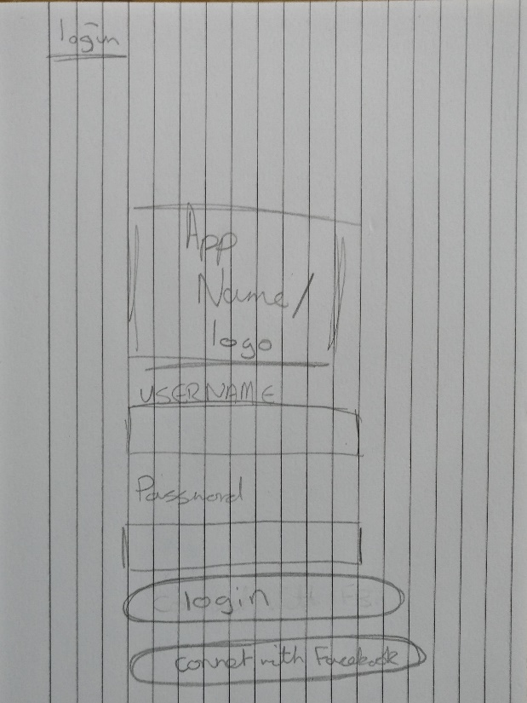

Figure 1- Paper design of application log in screen

Additionally, but not as crucial to the above points, Lean UX was already familiar to the author, the possesses and techniques involved in running a Lean UX project were already incorporated into the way the team conducted project development, which when considered alongside the other requirements of the project makes it a good fit as time spent developing skill with another project methodology could be better spent elsewhere.

Finally, despite the fact that Lean UX does not focus upon setting specific timeframes within a project, as a project should be considered finished when it meets its aims and objectives. This project must in the face of a real deadline be given a specific cut-off date. As such a Gantt chart was produced in order to maintain a good pace and stick to a timeframe that ensures project completion, as well as to allow for foresight when it comes to potential deadline clashes with other course related commitments. For reference to the Gantt chart please see Figures 2 & 3 below;

### 3.6.1 Gantt chart

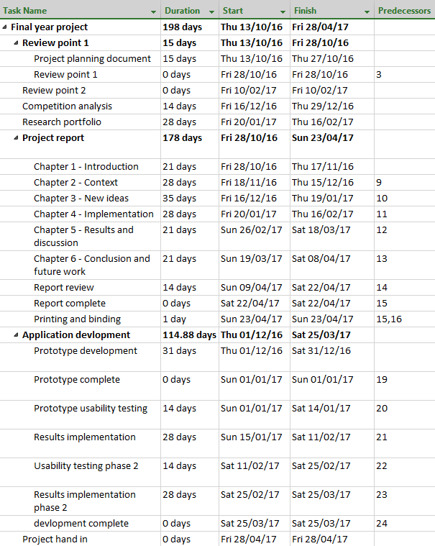

Figure 2 – Gantt chart in table form

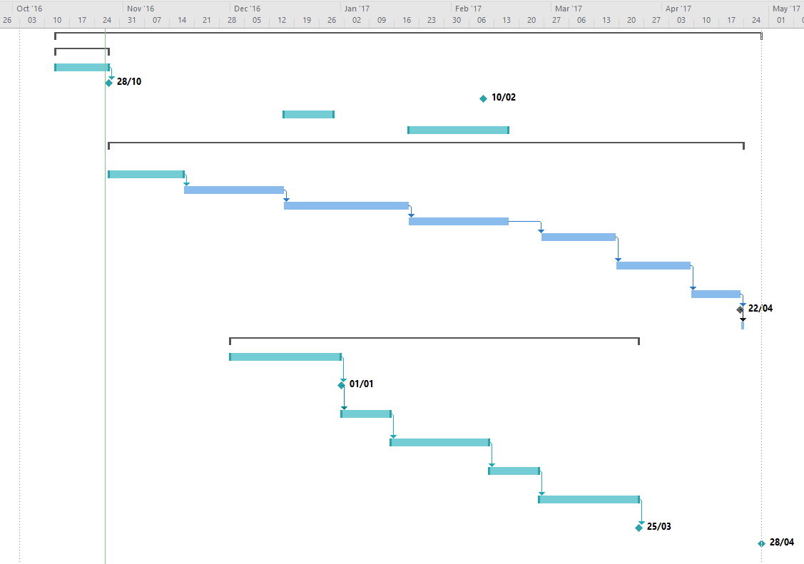

Figure 3 – Gantt chart

## 3.7 Investigation

The following section outlines the investigation that took place to identify the selected genre, theme and style of the proposed application, this investigation entailed researching current popular mobile games and assessing their viability for this project. In total five games were researched to assess viability, these games were selected due to their top five position on the Top Games by All-Time Worldwide Downloads list (The Most Popular Google Play Apps of All Time, 2016). The selected games are as follows;

* Subway Surfers
* Candy Crush Saga
* Pou
* Temple Run 2
* Hill Climb Racing

Once a suitable list of games with which to investigate had been established it follows that some criteria for the investigation would need to be generated, the criteria and their reasoning within the investigation was as follows;

### 3.7.1 Total downloads since release

Total downloads since release was selected as a criterion for the investigation as it provides evidence for what style and type of game is popular among users. This is a useful metric to track as designing an application which in some way attempts to take inspiration from what is currently popular has a greater chance of being itself successful.

### 3.7.2 Popularity with user demographic

As the application discussed in this report was being targeted at a specific age group, it stood to reason to investigate the popularity the games in the investigation had with the target demographic, this allowed for a greater chance that the design created from this investigation would prove popular with the target demographic.

### 3.7.3 Revenue generated

In preparation for potential future work related to the scientific questions briefly mentioned in the section above this metric has been added to this investigation as having the most solid foundation from which to work from will provide any future work in this project area the greatest chance of success.

### 3.7.4 General review

A final criterion explored in this investigation was a general review of the game by the author, in summary this general review would cover; what was good and bad about the chosen game and whether the game be suitable for development in this project, i.e. could a similar game be produced by a single member development team.

### 3.7.5 Conclusion

The investigation concluded that producing a game in the style of Candy Crush Saga would be the most suitable basis for the proposed application, this is due to the popularity of Candy Crush Saga among the target demographic, its high sale content for in game rewards, as well as the ease in which an application in its image can be created by a single member development team. Below find the investigation results for Candy Crush Saga, for all results from the investigation see Appendix B: Top five games investigation.

### 3.7.6 Candy Crush Saga results

**Google play release date:** November 2012

Figure 4 – Candy crush application icon

**Company:** Activision Blizzard

**Country of Headquarters:** United States

**Game link:** <https://play.google.com/store/apps/details?id=com.king.candycrushsaga&hl=en_GB>

**Total downloads since launch:** Over 500 million total downloads (Webster, 2017)

**Popularity among user demographic:** 40% total users fit user demographic profile (Newzoo, 2017)

**Revenue generated:** Dailyrevenue generation of an estimated $581,995 (Think Gaming, 2017a)

**General review:** The game design of Candy Crush Saga is best described as a Match 3, this being a game of swiping various colours of object on screen to match three in a row, this will remove the matched items, granting the player points towards the score requirement of the level. It is easy to see where the popularity of Candy Crush comes from, the game is incredibly simple but well made, the simplicity of the game lends itself to ease of access from a variety of different users and the bright colours and consistent feedback from the game as well as a manageable difficulty curve will draw the player in. The game also operates on the concept of lives that recharge after a certain period of time has passed, this can leave the player yearning to return to the if they are unable to complete their current level with their remaining lives.

It should be noted that the 2D nature of this game lends itself to this project as it will require less time to fully implement a working solution when compared to a 3D game

# Chapter 4 – Implementation

## 4.1 Introduction

The following chapter is focused around the development of the idea proposed in the Chapter Three. Within; a summary of the steps taken whilst following the Lean UX project methodology, the tools used for development are discussed with a focus on the reasoning behind this choice as well as a summary of key elements of the system that were developed with the aim of meeting the projects goals.

## 4.2 Lean UX project methodology

This section is a summary of the steps taken to accurately follow the process of managing a project using the Lean UX project methodology (Gothelf and Seiden, 2013). For a full writeup of the process and results of the individual steps please refer to Appendix C: Lean UX implementation.

The first stage of Lean UX is to identify a problem with the current status quo, this is to say some situation where the goals of a target audience are not being fully met. In this case, the problem identified in Chapter Three, was that there are no solutions that offer a more passive approach to user fitness and entertainment, and that the uses of such a solution have yet to be fully explored.

Once a problem had been identified research was conducted into the user demographic of the proposed application, this step is conducted as it aids in empathizing with the target demographic, and helps to identify any bias or false assumptions the project author may have. These steps are all in aid of creating a better targeted solution for the users. The result of this stage is a list of assumptions of the target audience.

Once the previous stage was complete any assumptions gathered were ranked in order of priority, the justification for this is to generate a testing schedule that focuses upon the highest priority items first. Priority is determined by a combination of two factors; knowledge and risk. Those assumptions where little was known of how valid the assumption was, but that presented a high risk to the projects failing were ranked as the highest priority and so required testing first.

With a prioritised list of assumptions, the next task was to develop a series of hypotheses, these are summaries of the assumptions discussed in the previous sections with the key difference that these hypotheses also contained a marker for their success. This allows for quantification of whether the hypothesis in question is in fact true and valid. Below are the two hypotheses that were established as a result of this investigation*;

“I believe my target audience would make use of an application that aims to produce an enjoyable experience but that offers them the opportunity to gain an in-game rewards if they complete a fitness based challenge. I shall be able to test this by producing a prototype application which combines the above elements, which I can then use to test with members of the target demographic. ”

&

“I believe one of the biggest risks to the success of this project is a lack of knowledge of whether my target audience want an application that aims to achieve the gaols laid out in this report, I can produce a paper prototype that will allow for a rapid testing session with my user base to conform or invalidate this hypothesis. “

*\*The format perspective of the hypotheses is in first person, this is in line with the guidelines of Lean UX (Gothelf and Seiden, 2013)*

The last step in this process is the creation of minimum viable products that are created to test each individual hypothesis for validity, in this case a paper prototype and an electronic prototype of the application were constructed as is in line with the requirements of hypothesis one and two. The results from the creation of these minimum viable products are discussed in Chapter Five.

## 4.3 Development

Within this section, the development of the application to fulfil the projects aims is detailed. First a development overview is explained to discuss the general architecture of the project application, which proceeds into a discussion around the tools used to achieve the required functionality, finally this section is rounded off by a more in depth look at some of the key functionalities within the solution.

### 4.3.1 Overview

The application developed to achieve the aims of this project can be split into three key components, a Node.js webserver, a mobile game and a wrapper application to link with the Google Fit API. The general functionality of these components as well as how they link together is discussed below, in addition to this a high-level system overview diagram is provided in figure 5 belowto aid in representing how the system operates;

Google Fit API wrapper – This section of the application is designed to request permissions from the user to gain access to their historical fitness data, once permission has been received, the application will then proceed to collect the fitness data relevant to the running of the overall solution. Once the relevant data has been collected it is then pushed to the Node.js webserver to be stored in the users datafile. Which shall be used later in the application when calculating fitness goals.

Node.js webserver – The Node.js webserver is designed to maintain security for the overall solution. Data relating to the user is stored in a secure server as opposed to the device and only the user profile in question is able to subsequently retrieve this data. Player and level information is stored within the server as to allow the application to be a lighter in weight. Additionally, storing this information enables the application to meet its goal of having a focus on social interactivity, as highscores between all players can be stored using the webserver to promote some competition between the application userbase. The webserver also enables functionality outside the scope of this project such as the ability to create cross platform applications that would run on several operating systems, as key data related to the running of the application is not stored locally. Finally, historical data can be stored on the usage of the application with the webserver, this will aid in future work outside the scope of this project but discussed briefly towards the end of Chapter Three and in more depth within Chapter Six.

Mobile game – As decided upon in Chapter Three the theme and style of the game used in this application is based upon the Candy Crush Saga, this being a match three genre game in which the player must reach a certain score be matching up three or more items on a screen. The mobile game is the only aspect of this project that is visible to the end user, as such it must meet all of the thematic styles of Candy Crush Saga the game decided as a base template for this application in Chapter Three. The game element of this solution pulls data relating to the player upon start, tracks the player’s fitness progress and provides motivation for further action through the use of rewards that can be spent in game on improving the players in game profile.

#### 4.3.1.1 System overview diagram

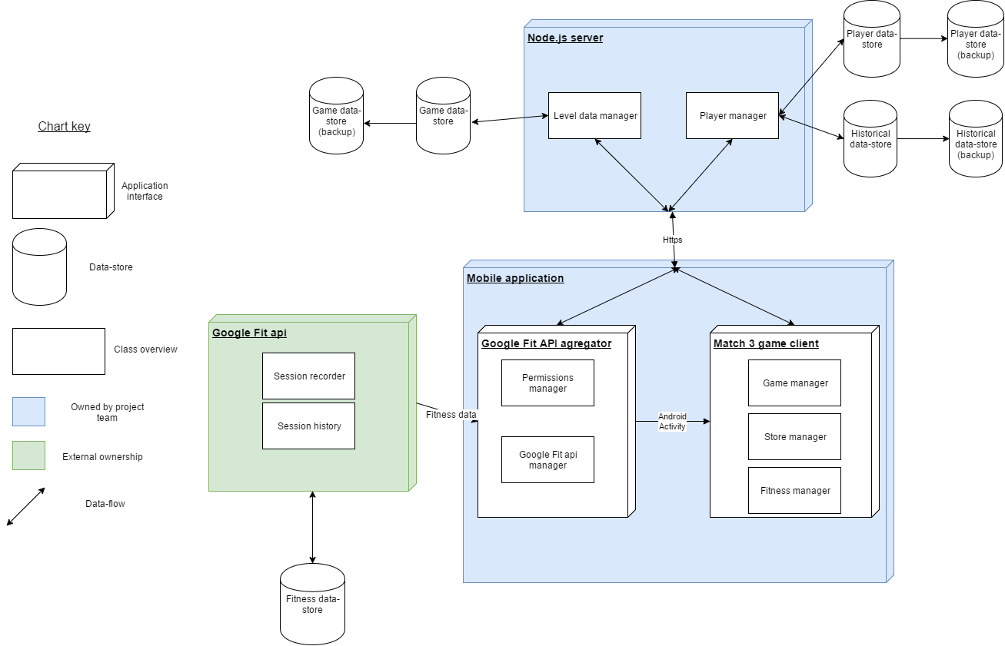

Figure 5 – High level system overview

### 4.3.2 Development tools

The following section outlines the main tools used during the development of this project as well as justifications for these choices. Additional tools such as Git, Photoshop and Atom were used throughout the project, however the contributions of these tools to the project are too minor to receive full discussion in this section.

#### 4.3.2.1 Android and Android studio

One of the objectives of this project is that the application should be designed to operate in on a mobile operating system, this is to allow for ease of access to the applications, as so long as the user has their mobile device with them they will be able to make use of the proposed application. Several operating systems are available that could be used to host the proposed application. Android has been chosen as the most suitable for the following reasons (Martin, 2016);

Android holds the largest market share of any mobile operating system, in Q2 2016 it saw a market share of 87.6% with Apple’s iOS holding 11.7%. Table 1 below shows the dominance of the android platform over other platforms between 2015 and 2016 (Martin, 2016)

Table 1 – Mobile phone operating system market share

|  |  |  |  |  |
| --- | --- | --- | --- | --- |
| **Period** | **Android** | **iOS** | **Windows Phone** | **Others** |
| **2015Q3** | 84.3% | 13.4% | 1.8% | 0.5% |
| **2015Q4** | 79.6% | 18.6% | 1.2% | 0.5% |
| **2016Q1** | 83.4% | 15.4% | 0.8% | 0.4% |
| **2016Q2** | 87.6% | 11.7% | 0.4% | 0.3 |

Google hold a userbase of 1.4 billion active Android users (Martin, 2016), such a high user base would enable the application to gain access to a greater number of potential users improving upon the validity of any potential scientific testing conducted within the realms of this project

#### 4.3.2.2 Justification for a single platform approach

With android set as the primary choice of operating system, the question did present itself as to what method of development would be used to produce the Android code, indeed there were several options available each offering different feature sets, some of the options present such as Cordova and HTML5 presented the opportunity to create an application that would work cross platform with Android, IOS and within a Web browser (Vensi, Inc., 2017; Rajput, 2017). However, these options were passed up in favour of developing through Android Studio with Java for the following reasons;

Google Fit is an open API that comes installed in Android phones operating version 2.6 and onwards (Google Developers Android API, 2017), this represents a significant portion of the android userbase (Developer.android.com, 2017), as the application proposed in the report intended to use fitness data to improve the users experience with the app the use of the Google Fit API was a crucial piece of functionality. The choice of Android Studio was in a large part influenced by this key functionality as access to the Google Fit API was not available through the presented other options as the trade-off of having multiplatform availability meant the lack of access to functionality native specifically to the Android platform

Android Studio also provides the use of the Android Virtual Device manager (AVD), the AVD allows for the testing of an application on devices with multiple different configurations such as operating system version and screen size, as the proposed application is designed to appeal and work for a large audience, testing with these variations is another key reason Android Studio was chosen as the platform of development for this project.

#### 4.3.2.3 Node.js, Express and CouchDb

The tools discussed in this section combine to make up a web server set up to host and manage the application.

Node.js is a community driven JavaScript based programming language that allows for non-blocking I/O in an event-driven architecture (dzone.com, 2017). Node.js has been found to be 10 times faster in I/O operations than competitors such as Java (Tilkov and Vinoski, 2010). This is achieved using an asynchronous event loop that does not block up other requests, this allows Node.js to offer a performance that does not decrease with a higher number of web calls. The choice of Node.js for this project is due to its ability to scale well with simultaneous web calls, this will allow the application to scale easily with an increasing user base without the need for any substantial changes to the server architecture.

An additional justification behind the choice of Node.js is the community behind it, with the use of the Node Package Manager (NPM) users have easy access to packages created by the community to fulfil many different requirements, one such package available through the NPM is Express. Express is a web application framework that allows for the relatively simple creation of a RESTful API that in the scope of this project will allow the mobile application to send data to and receive data from the application server. Express was chosen as the most suitable method of managing the http server as it is designed to be light weight and easy to use as well as the documentation available for Express is widely available and well maintained.

The final component within the http server architecture is a database with which to store data to allow the application to be persistent even if a user were to swap their primary mobile device. CouchDB a NoSQL JSON document based database was selected for use in this project due to its ease of use, especially within a JavaScript based environment as the JSON based format used by CouchDB allows for simple translation across multiple languages. The API used to access CouchDB is written in REST, this matches up with the use of Express meaning there will be no additional overhead required to pull documents and send them from the server.

The point could be argued that an SQL database would have performed as efficiently in this project as CouchDB, the justification for using a NoSQL database over one based on SQL is also related to the choices of all the tools that make up the web server, developer preference. Whilst in industry on placement the author gathered experience using the tools discussed in this section as these were a part of the tools used daily by several teams within the organisation.

#### 4.3.2.4 Unity and C#

The final major tool used throughout the development of the project, Unity and by extension C# (as this is the primary development language within Unity) is a freely available, cross platform game development tool kit that can be used to develop 2d or 3d games. As Unity is able to produce applications that work natively on Android it satisfies the major project requirement of creating an application that targets mobile devices. Unity was selected over other available tools such as Unreal Engine and LibGDX for a number of reasons;

Unity is extremely popular amongst mobile game developers with 34% of the top 1000 free mobile games being created using unity (Unity, 2017), as such the community around the tool is also vast meaning access to documentation for Unity is readily available and simple to find.

The drag and drop nature of the Unity interface is clean and easy to understand, this also enables the user to focus more on the functionality of the game as opposed to the rendering of items within a scene, as this is done by Unity automatically (Craighead, Burke and Murphy, 2007).

It should be noted however that during the course of this project, issues did arise with the use of Unity that could have been overcome through the use of a different library such as LibGDX, these issues will be discussed in greater detail in the sections below.

### 4.3.3 Key features

Within this section, the key features of the application will be discussed with a focus around the functionality they provide, and the justification for the implementation of these features in the manner chosen.

#### 4.3.3.1 Paper prototype

In accordance with the Lean UX project methodology it was determined that a paper prototype would constitute the minimum viable amount of work required to test whether there would be user interest for this application as defined in Hypothesis 2, below in figures 6 & 7 show screen shots of the paper prototype that was developed for this purpose, for the full paper prototype please see Appendix D – Paper prototype design.



Figure 6 – Paper prototype example A: Application log in screen

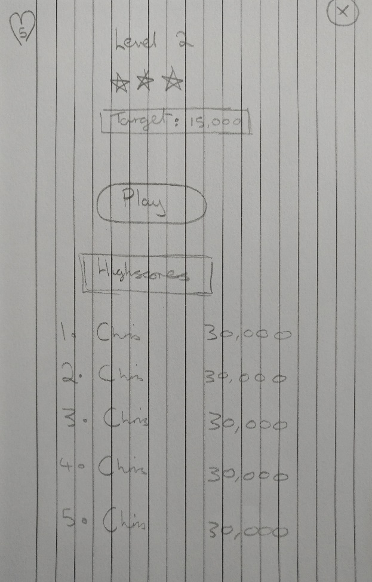

Figure 7 – Paper prototype example B: Level start screen

#### 4.3.3.2 Candy Crush Style Match 3 Game

At the close of Chapter Three it was determined the most suitable game for development that would meet the goals of the project was a game in the style and genre of Candy Crush Saga, this being a bright and colourful theme wrapping around a game of the match three genre. Following the ideals of Lean UX to create a minimum viable product as quick as possible to test the defined hypotheses, an open source guide on the creation of a match three game was followed as well as assets used within this guide were also incorporated into this project (Dgkanatsios, 2015). This guide detailed the core gameplay mechanics of a match three game such as the functionality of swapping objects on screen to generate score and the subsequent spawning of new randomised objects to take the place of those previously destroyed through swapping. However, the guide only went this far and gameplay elements such as level management encompassing; remaining moves, score objectives, score keeping, highscore recording, and a lives total were not a part of this guide, so required development for this project. Figure 8 below is a screen capture of the application running.

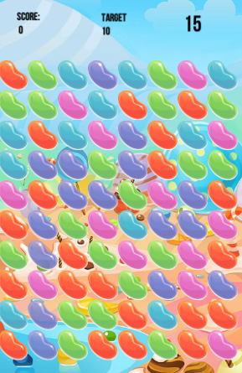

Figure 8 – Screen capture of running application

In addition to the developed game play, the game element of this project required close integration with the game server, this was to enable data to pass through the Unity application but not exist persistently on the user’s mobile device, the benefits of this have already been discussed. To enable this functionality an older version of the .NET framework was used to create a REST API interface that could communicate with the Node.js server, an older version of .NET was utilised for this purpose as the version of MonoDevelop; the tool unity uses to build C# code is not currently compatible with more modern versions of .Net (Paczkowski, 2017). Issues were faced in making use of POST requests through the developed RESTful interface, this was due to the security settings present in the webserver and the content tags added when building a URL request in C#. The problem was overcome by altering the way in which requests were sent to the server to rely more on GET calls as opposed to the previously mentioned POST calls.

The fitness motivation functionality was integrated into an activity named “Quests” that would provide context to the user of their current steps taken since accessing the application, if the user is able to reach a certain number of steps they are rewarded with in game currency which could be spent in a Store activity. The Store activity contains a couple of items the user can spend in-game currency on that are designed to improve the game experience for the player, the items currently available are focused on either refreshing the players lost lives, or increasing the total number of lives the player has available to them. Figures 9 & 10 showcase the Store and Quests activity.

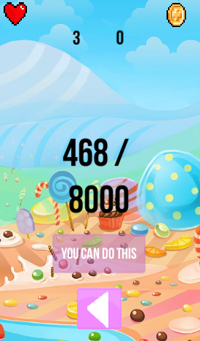

Figure 9 – Screen capture of application rewards activity

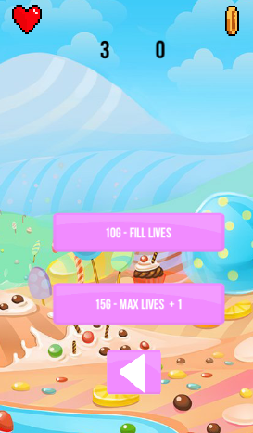

Figure 10 – Screen capture of application store activity

One final area within the Unity portion of the project worth note is the Highscore activity, the activity is designed to retrieve the current highscores for individual levels so players are able to compare their scores to that of other players, the aim of this is to attempt to kindle some social competition between the user base, this matches up with the project objective of making an application that has a focus on social interaction. Figure 11 below showcases this functionality.

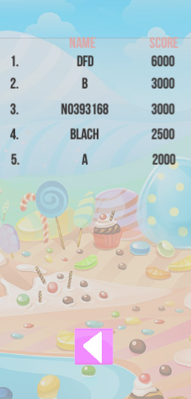

Figure 11 – Screen capture of Highscore activity

#### 4.3.3.3 Node.js Webserver

A Node.js server was created to implement the following functionalities;

##### 4.3.3.3.1 Social user interaction

With the project objective in mind of creating a game that allows for some form of social interaction between users, the Node.js server would allow for data concerning individual player’s performance in game to be stored in a database separate from the user’s physical device, this allows the game controller present on a user’s device to request information such as other players scores resulting in the functionality for a globally available high scoring system. In its current state the webserver has functionality enabled to record and retrieve a global high score system as well as the ability to retrieve the high scores of users within a certain range, this allows a user to see the scores of other users who are close to their score for a particular level with the goal of fostering some competition and interaction between these users.

##### 4.3.3.3.2 Anti-cheat safeguard

Despite the low probability of this occurring, an additional reason behind the choice of a Node.js webserver was to remove the opportunity for cheating within the user base. Game development guidelines suggest that using a webserver to handle updates to player information where possible is a sensible move as it guards against any possibility for foul play (Bramer, 2014). This functionality is achieved by making the player controller within the game send requests to the server when a major game event occurs, such as when a player fails a level and loses a life. The player controller sends a message to the server updating it of the event, the server will then go through the steps of updating the player’s information and initiates a function to refresh the players missing lives.

##### 4.3.3.3.3 Historical data

The final major element of the Node.js webserver is functionality designed around the ability to store historical data about the applications usage over time, recording historical data opens up the ability to monitor the success of the application by checking how often users are logging in and making use of the various features of the application. Historical recording also opens up the possibility for further research such as the potential research questions discussed briefly towards the end of Chapter Three and in Chapter Six.

##### 4.3.3.3.4 System Overview

Below are two system overview diagrams, the first figure 12shows the interaction between the node server and any clients at the highest level, the second shown in figure 13 shows a slightly more complex representation of the system process of when a user fails a level in the Unity application and actions the server takes on this event.

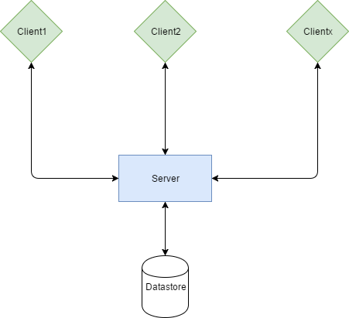

Figure 12 – High level data flow diagram between client and server

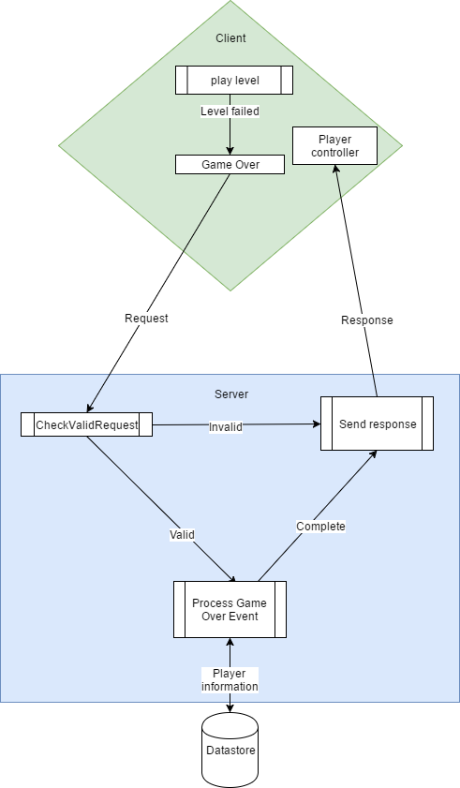

Figure 13 – User level failure system process

#### 4.3.3.4 Google Fit API

Despite Unity hosting much of the mobile application code in this project, the functionality around collecting fitness data, essential to the aim of this project was inaccessible to the platform due to its nature as a cross platform entity having to balance many plates at the same time. To gain access to the user’s fitness data a wrapper application was created using Android Studio that would gather the required information and send it to the Node.js webserver, wherein it could be assessed by the game portion of the project.

The wrapper application had functionality to determine the current user of a mobile device, establish a connection to the Google Fit api, then pull a variety of different historical fitness data types from the users fitness store. The Google Fit API has access to several types of data that were considered for use in this project such as;

“com.google.calories.expended“ - This data type would return the total calories expended by the user within a given timeframe. An implementation of this data type could have required the user burn a certain number of calories to receive an in-game reward. However, this method of reward was passed over due to its lack of interactivity and in relative terms quantifiability, as calorific burning would be difficult to for a user to convert in to what actual exercise is required to meet said goal, this is especially so when such a goal could simply be set by the application as opposed to one based on calorie burning

“com.google.activity.summary” – The activity summary datatype is able to return full fitness activities the user partook in within a given timeframe, this opened up the possibility of setting up more challenging goals for users, for example to partake in an activity that involved using a bike. However, this complexity was ultimately the reason this data type was not used, as it did not really fit in with the applications goal of creating an experience that doesn’t require a high amount of engagement in its fitness aspect

“com.google.step_count.delta” – The delta step count data type can be used to return the number of steps a user has taken within a given time, this can therefore be used to determine the number of steps a user took during a single day. This datatype was chosen as the basis value with which to build the fitness portion of the application around.

With a metric selected to base the fitness element of this application from the next step necessitated enabling this functionality in a way the user could interact with it. With this goal in mind a system was set up within the Unity project that allowed users to claim a daily reward of in game currency for attaining a certain number of steps each day. At present the current daily target for all users has been set to 8000 steps, this value has been chosen based on the findings presented in Tudor-Locke and Bassett (2004), in which up to 7500 steps is considered within the norm for general activity throughout a day, with the goal being set only slightly above the realms of normal activity a user may become motivated to achieve their daily goal if they are able to see how close they are to achieving it.

Rewards generated from taking part in the fitness aspect of the application are required by the project objectives to provide some in game benefit, to this end when a user completes their daily goal they are granted in game currency, which can be used to purchase a number of player bonuses, such as the ability to fully refresh the character’s life count, and a purchase that increases the players maximum available lives.

#### 4.3.3.5 Integration of all components

One key area to this project was in fact making sure all elements were able to interact well with each other, in some projects where for example only one tool is used, integration of an applications classes can be a simple process so long as the development is well thought out and planned ahead of time. However, in this project many unforeseen issues were caused when attempting to combine applications elements together, for example when exporting the game element of the project from Unity to Android, Unity would often overwrite sections of the wrapper application, whilst this issue was mitigated through the regular use of source control, being able to identify what components required manual integration was no small task. Another issue faced during development was through gaining access to the account name of the user once the application had loaded into the game, functionality was in place to fetch the Android account name from the Android wrapper which would then pass it to the Unity application, however due to the way in which the Unity application handled Android Activities this approach would not work. Eventually an entirely new approach required use to enable the Unity project to gain access to the Android account name.

# Chapter 5 – Results

## 5.1 Introduction

Chapter Three established the lack of a solution currently available that operates using a casual fitness model, this being an application that can be operated by the user without any fitness elements, however, should the user wish to, they can make use of the in-built fitness elements within the application to gain some reward within the context of the application itself, this being in addition to the general benefits fitness has on the body.

Based on the above, if the application discussed in the previous chapter meets the aim of the project, this being; To create a socially interactive mobile based game targeted at older adults, that gives the player character an in-game advantage determined by fitness data captured through their mobile device then, a novel solution that has not previously been created and explored should have been produced. To confirm or disprove this, in the following sections the final version of the application presented in Chapter Four is compared to several metrics which have been established in previous chapters.

The metrics that shall be used in this investigation are; results from user testing sessions conducted throughout development, the project objectives, the project test plan and the hypotheses as defined through the use of the Lean UX project methodology, below find each individual metric discussed in detail regarding whether the solution presented has been able to match the criteria of the aforementioned metric.

## 5.2 User Testing

To verify the project was following its aim of creating a solution targeted to a specific demographic, and as a method of maintaining code quality and functionality User testing was conducted on a number of occasions throughout the course project, this section summarises this process.

### 5.2.1 User testing overview

Based on the findings of research conducted in (Martin, 2017), Empirical Usability testing was selected as the most appropriate method of usability testing, this was due to the low requirement of participants within the study, as finding suitable candidates with which to test was an issue throughout the testing phase of this project. Again, following the work in (Martin, 2017) as a final metric of testing on the system, participants will complete a System Usability Scale test (Brooke, 1996), this choice was down to the system usability test being a well-established tool for getting a standardised comparable set of results, which would be unavailable in a project if the project team decided upon their own metrics for analysis.

### 5.2.2 User testing results

In this section, the final user testing session has been summarised in table form with an analysis of the testing results presented after the table. As with the formal process that goes along with Empirical Usability testing a documented testing guide is available for review in Appendix E – Usability plan template**,** which among other things gives a more in depth look at the tasks performed during testing (Dumas and Redish, 1999), a review of the users taking part in the session, and a clear definition of the conditions of whether a test passes or fails. Below in Table 3 find a summary of the results from the usability testing. Consent forms and System usability scale results for each user can be found in Appendix F – Usability testing consent and Appendix G – System Usability Scale results.

Table 2 – Usability testing summary table

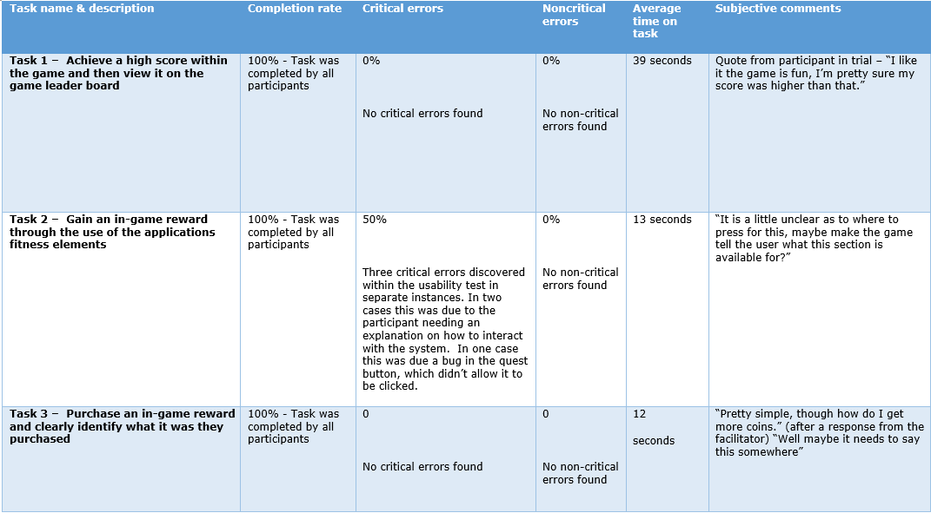

#### 5.2.2.1 Interpreting summary table

Three tasks were monitored during the usability analysis, results have been recorded and are present in the table abovethe following can be determined through examination of this table;

* All participants completed the tasks set
* Three critical errors were found during the test, all of which were found within task two
* No non-critical errors were discovered during the usability test
* The rate of critical errors reduced to zero as the usability test progressed
* The average time to complete a task fluctuated throughout the tasks, task 1 presented the greatest range of results, though this can be attributed to the nature of the task
* User feedback from task one was generally positive
* Feedback from the remaining tasks was generally negative as a result of the application not providing enough feedback to the user

### 5.2.3 User testing task time distribution

Table 3 – User testing time distribution per user for each task

|  |  |  |  |  |  |  |
| --- | --- | --- | --- | --- | --- | --- |
|  | User 1 | User 2 | User 3 | User 4 | User 5 | User 6 |
| Task 1 | 33 | 41 | 45 | 30 | 37 | 50 |
| Task 2 | 11 | 9 | 17 | 11 | 18 | 10 |
| Task 3 | 10 | 17 | 13 | 15 | 7 | 11 |

### 5.2.4 SUS test results

Table 4 – System Usability Scale results

|  |  |
| --- | --- |
| User | SUS score |
| User 1 | 72.5 |
| User 2 | 72.5 |
| User 3 | 67.5 |
| User 4 | 62.5 |
| User 5 | 62.5 |
| User 6 | 30 |
| Mean score | 61.25 |

#### 5.2.4.1 Interpreting SUS score results

SUS scores fall on a scale of 0-100 with 0 being the worst score possible and 100 the best, analysis of the results from the Usability test suggest a system that for the most part is on the positive side of the scale, when SUS scores are compared to adjective measurements the scores on both correlate well as seen below in table 1(Bangor, Kortum, and Miller, 2009). When compared to an adjective scale the SUS score gained from the usability analysis suggests this application sits between an average design and a good one, this suggests that the design needs to be reworked as not all users considered it “good”. 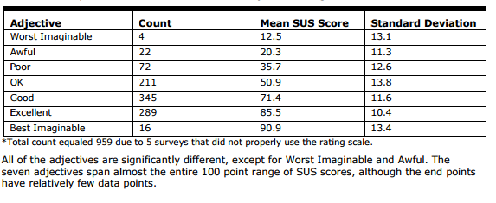

Figure 14 - SUS score to adjective rating comparision of 959 tests (Bangor, Kortum, and Miller, 2009)

### 5.2.5 User testing summary

Results presented from the user testing sessions in combination with results from the System Usability Scale test show an application that is simple to use among users within and outside of the targeted user base, this was shown by a completion rate of 100% across all tasks within the usability test as well as a positive rating from the System Usability Scale test with a mean score of 61.25. One area that does require attention however is in adding further context to the user’s actions when they using the game, this is in specific relation to tasks focused around earning and claiming rewards relating to the fitness elements present within the application.

## 5.3 Project objectives

Perhaps the most important of the judging criteria, the project objectives act as small aims which when taken as a collective should form the overall aim of the project, table 5below denotes the objectives of the project as well as a result for whether these objectives were achieved. Results on whether objectives have been met are based on the project solution and user testing results above.

Table 5 – Project objective test results



The solution presented in the previous chapter was able to pass all of the objectives outlined in Chapter Three; the presented application followed a theme and style that would be pleasing to the target demographic, the application has been built with access to a fitness data store and offers users an in-game reward for achieving goals based on the user’s fitness activity.

At the end of the project implementation three objectives were only considered partially passed, these are Objective 3 and Objective 4 due to its association with Objective 4.7. The root cause of these objectives only partially passing is as a result of insufficient user testing, whilst multiple testing sessions did take place, in the opinion of this author, not enough user testing was conducted in order to impact the design and development of the presented solution.

## 5.4 Test plan

At test plan was developed at the outset of the project in order to accurately identify the functionality the application would need to implement so as to meet the aims of the project. As opposed to the project objectives which are a high level overview of the whole project, the test plan is able to be much more concerned with making sure the application does what it is intended to do in a bug free manor. The test plan was split into three sections relating to the different components of the project these being; the Android hosted Google Fit API integration, the Node.js based webserver and the Unity based game client, the test results of these individual components are discussed below.

### 5.4.1 Google Fit API integration

Below in Table 6are the results from the Google Fit API integration section of the test plan, of five tests all were able to pass, however two of the tests, these being tests ID’s GF3 and GF4 are only considered partial passes the reasons for this are as follows;

GF3 – The system is able to initially handle multiple users logged into the application , a dialog is presented that offers the user a choice of who’s fitness data will be integrated into the application, however upon subsequent runs the user is no longer presented with this dialog, this is an issue due to the underlying way android asks for device permissions, a solution to this would require revoking and asking for device permissions whenever the application loads, which would present a worsened experience for the user.

GF4 – This test is considered a partial pass as whilst the system would still work if the Google Fit permission is not granted by the user, functionality in the system would be diminished. In addition to this the “Quests” activity present in the Unity solution does not react to the lack of this permission, when ideally it should explain why the app needed the permission in the hope of the user reconsidering their decision.

Table 6 – Google Fit API test results



### 5.4.2 Node.js webserver

Below in Table 7,these results show that all tests passed with the exception of test ID’s WS6 and WS7, this is discussed below;

WS6 & WS7 – An aspiration for the development of this project was to store historical data on the applications usage which could be used in further work to help improve upon the implementation of the solution or as a means to help answer the scientific questions that were discussed briefly in Chapter Three. However, as this was not an objective within the current scope of the project, the functionality described in test cases WS6 & WS7 which would have worked towards this goal was dropped in favour of not having the users device sent an event whenever the triggers described in the test cases was fired, this was to reduce the networking cost to the user, as well as to avoid any potential network related programming errors that could have resulted from this functionality.

Table 7 – Webserver test results



Unity game client

The final section of the test plan consisted of the functionality that made up the Unity game client, the results for this test plan game be viewed below in Table 8. Of the cases present in this section only test cases G15 and G16 failed, the reason for this failure is due to a lack of development time for a tutorial and information section within the produced application. The tutorial and information activities were pushed back as they were considered superfluous during the user testing phase of the project as test subject were informed on the nature of the application before testing took place. In Chapter Six within the future work section, a sufficient tutorial is one of the discussed topics.

Table 8 – Game client test results



### 5.4.3 Summary

Whilst some of the tests outlined in the test plan have failed they do not impact on the way in which the user interacts with the application, this can be seen as the user testing report section available above did not identify any issues for the user in terms of application functionality, as such the presented application passes the test plan but will require additional future work in order to improve upon the partially passing tests as well as fixing those tests that currently fail.

## 5.5 Lean UX hypotheses

The Lean UX project methodology requires practitioners create hypotheses, which are testable statements based on the projects highest risk assumptions, in Chapter Four, two hypotheses were created based on the authors assumptions of the project area, in the following section these hypotheses will be reviewed for their accuracy and determined to be true or false.

### 5.5.1 Hypothesis One

#### 5.5.1.1 Hypothesis statement

“I believe my target audience would make use of an application that aims to produce an enjoyable experience but that offers them the opportunity to gain an in-game rewards if they complete a fitness based challenge. I shall be able to test this by producing a prototype application which combines the above elements, which I can then use to test with members of the target demographic”

#### 5.5.1.2 Conclusion

Based on the feedback from the user testing sessions detailed above, it is still difficult to suggest whether this hypothesis has been proven true or false, this is to say that the testable element to this hypothesis is whether the application will see use from its user base, and whilst this was true during the testing session it is unreasonable to assume the application will see wide use once users are not involved in a formal testing process. For this hypothesis to truly be confirmed or disproven a couple of options are available, either;

The testing of the application is extended with a focus slowly shifting as the test subjects become accustomed to the application to their general attitude to the application and whether they would see themselves using it outside of the designated formal testing sessions.

The application is released to the public via a medium such as the Google Play store, usage statistics present through this medium and built into the application itself will generate data on whether the application is being used as the hypothesis statement requires

### 5.5.2 Hypothesis Two

#### 5.5.2.1 Hypothesis statement

“I believe one of the biggest risks to the success of this project is a lack of knowledge of whether my target audience want an application that aims to achieve the gaols laid out in this report, I can produce a paper prototype that will allow for a rapid testing session with my user base to conform or invalidate this hypothesis. “

#### 5.5.2.2 Conclusion

The result for hypothesis two is in fact identical to that of hypothesis one, it is currently unsuitable to confirm or invalidate the hypothesis based on the currently available data, the most suitable course of action at this stage is to follow the steps outlined in the Hypothesis One: Conclusion section above and proceed with releasing the application in order to generate results for whether this hypothesis will pass or fail.

# Chapter 6 – Conclusion

## 6.1 Project summary

The work presented in this report showcases a novel solution to the growing problem of obesity within developed countries such as the United Kingdom. This is in the form of a socially interactive mobile based game targeted at older adults, that gives the player character an in-game advantage determined by fitness data captured through their mobile device. The novelty of this solution comes from the method in which the fitness elements are implemented. Where other fitness applications set the primary focus of the solution to be purely around improving the user’s fitness, this solution instead has the fitness functionality as an accompaniment to other functionality present in the application. This means that the application can be used without burden if the user has no interest in improving their fitness. The hope of this, is that users with limited motivation to take part in fitness activities will develop this through typical use of the application as they become invested in their player character. Whilst the implications of this are not explored in this project, there is scope to do so in future work, this is discussed in the section below.

Chapter Five investigated several metrics which would suggest whether the presented application was successful in achieving the aim of the project. Of these metrics only the hypotheses, developed through following the Lean UX project methodology, would be considered as a point of contention when suggesting the project aim had been met. This is due to the fact these hypotheses have yet to be confirmed or proved false, as discussed in that section of Chapter Five this is due to the lack of data present during the testing of this solution. However, as the solution presented has passed user testing sessions, the test plan, and achieves all of the objectives as defined in Chapter Three, the project should be considered successful in achieving its aim, this being; To create a socially interactive mobile based game targeted at older adults, that gives the player character an in-game advantage determined by fitness data captured through their mobile device.

However, the project should be considered in the larger context of similar work in the field and whether the project was able to build off of this similar work to add something entirely new. Consolvo et al. (2006) suggested that a well-designed fitness based application should “support social influence”, “give proper credit for user activity” and “consider the practical constraints of the user’s lifestyle”. The presented application meets all of these ideals, step targets are set slightly above the high-end average of a user’s average everyday step total (Tudor-Locke and Bassett,2004), highscore recording is implemented in order to promote some social interaction between users, and the user is provided with an in-game benefit for completing the fitness goal set for that day. The results from the study conducted by Lin et al. (2006) showcased the importance that any solution had to be built as not encumber the user, to this end the application was built using an API available to all Android users requiring no additional downloads or set up on the part of the end user. The work for Warburton et al. (2007) showed that a contributing factor to a user’s motivation to participate in fitness activity is an element of fun and enjoyment, the application presented has been developed as a game for this reason. This research contributed to the development of this application but as stated above the method of combining the fitness elements in this solution with the game elements is what sets this solution apart as something novel and unexplored.

### 6.1.1 PESL issues

#### 6.1.1.1 Professional

Within the scope of the project, there are no foreseeable professional issues that require consideration, because of this the project will have a low professional impact.

#### 6.1.1.2 Social

The proposed application is an attempt to improve the fitness and lifestyle of its user base, this beneficial social impact needs to be at the forefront of development and be promoted to the users of the system, for this reason the project will have a high social impact.

#### 6.1.1.3 Ethical

The way in which this application attempts to motivate it’s userbase to take part in fitness based activities could be considered manipulative, despite the intentions of this being for the benefit of the user if in future work this method proves effective it could lead to more sinister implementations. Because of this any future work within the realms of this projects scope should plan for a prominent level of Ethical impact.

#### 6.1.1.4 Legal

Due to the way the application functions, user data is stored within a database, this requires the project follow laws surrounding data protection. The primary law in the UK for dealing with data protection is the Data Protection act 1998, which states a user’s data must only be used for “limited and specifically stated purposes” and “kept for no longer than is absolutely necessary” (Data protection, 2016). As the legal implications for mishandling a user’s personal data are so high, the legal impact of this project is considered high, to minimise the potential risk the Data Protection act must be studied and adhered to always during the project.

## 6.2 Future work

### 6.2.1 Scientific questions

In Chapter Three several scientific questions were raised as possible areas of study based off the concept of this project underlying idea, these areas of study were deemed to be out of the scope of this project but the exploration of these ideas in future work could prove to be scientifically significant, the questions raised in the chapter are discussed in the sections below.

#### 6.2.1.1 Question 1

Will users will make use of an application with this type functionality above currently available alternatives?

As discussed in the New Ideas chapter an application that takes a passive approach to fitness has not been explored before, this could be as there is no need for such an application, however the question is worthy of exploration with further research.

#### 6.2.1.2 Question 2

Will users with little or no desire to take part in regular fitness develop motivation to do so through use of this application?

Studies have shown that enjoyable social applications can motivate an individual to take part in a more active lifestyle (Lin et al., 2006), the question posed above, is again based on the notion that an application of this style hasn’t been explored currently. Perhaps results will show that this type of application where the fitness elements are available on choice rather than at the forefront of the solution, will be able to provide more motivation for users to take part in more fitness activities.

#### 6.2.1.3 Question 3

Will users who currently spend real world money on in game rewards be more or less likely to make use of this applications reward system when compared to individuals who spend no money on virtual game rewards?

The video game industry generates vast amounts revenue as a result of small transactions made within a game that grant the player some improvement to their gameplay experience. The application this project is thematically based around, Candy Crush Saga generates a dailyrevenue of an estimated $581,995 (Think Gaming, 2017a), whilst not all of this is based on these in-game transactions it is reasonable to assume at least a small percentage is. It would be interesting to test whether this application with its in game purchase system being based around fitness activity as opposed to financial cost, would be seen as more attractive to individuals who actively partake in the purchasing of in game benefits. This can be expanded further to test if the aforementioned individuals would be more likely to make use of the in-game reward system when compared to individuals who do not purchase in game benefits.

### 6.2.2 Application release

An additional area of future work that could be explored, would be to release the application onto publicly available application stores. To proceed with this however the application would require further development, with at the very least an attempt to produce a cross platform implementation of the application in order to open up to a wider potential userbase. Beyond this further development of the features present in game would also be highly desired. Whilst the current feature set is enough to meet the aim of the project, in this authors opinion these features would require expansion in order to appeal to the general public.

# References

Vandewater, E., Shim, M. and Caplovitz, A. (2004). Linking obesity and activity level with children's television and video game use. Journal of Adolescence, 27(1), pp.71-85.

The State of Food and Agriculture. Rome: Food and agriculture organization of the United Nations, 2013. Web. 4 Dec. 2016.

2016 GLOBAL GAMES MARKET REPORT (2016) Available at: https://newzoo.com/solutions/revenues-projections/global-games-market-report/ (Accessed: 25 October 2016).

Consolvo, S., Everitt, K., Smith, I. and Landay, J. (2006). Design requirements for technologies that encourage physical activity. Proceedings of the SIGCHI conference on Human Factors in computing systems - CHI '06.

Stephenson, T. (2013) Measuring Up The medical profession’s prescription for the nation’s obesity crisis. Available at: http://www.aomrc.org.uk/wp-content/uploads/2016/05/Measuring_Up_0213.pdf (Accessed: 04 December 2016).

Thompson, D., Baranowski, T., Buday, R., Baranowski, J., Thompson, V., Jago, R. and Griffith, M. (2008). Serious Video Games for Health: How Behavioral Science Guided the Development of a Serious Video Game. Simulation & Gaming, 41(4), pp.587-606.

Lin, J., Mamykina, L., Lindtner, S., Delajoux, G. and Strub, H. (2006). Fish’n’Steps: Encouraging Physical Activity with an Interactive Computer Game. Lecture Notes in Computer Science, pp.261-278.

Preacher, K.J. and Hayes, A.F. (2008) ‘Asymptotic and resampling strategies for assessing and comparing indirect effects in multiple mediator models’, Behavior Research Methods, 40(3), pp. 879–891. doi: 10.3758/brm.40.3.879.

Kendzierski, D. and DeCarlo, K. (1991). Physical Activity Enjoyment Scale: Two Validation Studies. Journal of Sport and Exercise Psychology, 13(1), pp.50-64.

Pate RR. Physically active video gaming: an effective strategy for obesity prevention? Arch Pediatr Adolesc Med. 2008;162(9):895–896

Purnell, JQ, Knopp, RH, Brunzell, JD, Willett, WC, Bray, GA & Popkin, BM 1999, 'Dietary fat and obesity [4] (multiple letters)' American Journal of Clinical Nutrition, vol 70, no. 1, pp. 108-110.

Mullins, N., Tessmer, K., McCarrol, M. and Peppel, B. (2012). Physiological and Perceptual Responses to Nintendo® Wii Fit™ in Young and Older Adults.

Warburton, D., Bredin, S., Horita, L. and Rhodes, R. (2007). The health benefits of interactive video game exercise.

Terry, K. (2017). Number of Health Apps Soars, but Use Does Not Always Follow. [online] Medscape. Available at: http://www.medscape.com/viewarticle/851226 [Accessed 4 Dec. 2016].

The Most Popular Google Play Apps of All Time. (2016). [online] App Annie, pp.10-11. Available at: http://go.appannie.com/report-top-google-play-apps-all-time [Accessed 12 Jan. 2017].

Candy Crush saga – Android Apps on Google play (2016) Available at: https://play.google.com/store/apps/details?id=com.king.candycrushsaga&hl=en_GB (Accessed: 12 November 2016). (Candy Crush saga – Android Apps on Google play, 2016)

Webster, A. (2017). Half a billion people have installed 'Candy Crush Saga'. [online] The Verge. Available at: http://www.theverge.com/2013/11/15/5107794/candy-crush-saga-500-million-downloads [Accessed 24 Feb. 2017].

Fowler, M. and Highsmith, J. (2001). The Agile Manifesto. 1st ed.

Gothelf, J. and Seiden, J. (2013) Lean UX: Applying lean principles to improve user experience. Sebastopol, CA: O’Reilly Media.

Think Gaming. (2017a). Candy Crush Saga. [online] Available at: https://thinkgaming.com/app-sales-data/2/candy-crush-saga/ [Accessed 24 Feb. 2017].

Think Gaming. (2017b). Subway Surfers. [online] Available at: https://thinkgaming.com/app-sales-data/18/subway-surfers/ [Accessed 24 Feb. 2017].

Think Gaming. (2017c). Temple Run 2. [online] Available at: https://thinkgaming.com/app-sales-data/341/temple-run-2/ [Accessed 24 Feb. 2017].

Think Gaming. (2017d).Hill Climb Racing. [online] Available at: https://thinkgaming.com/app-sales-data/49/hill-climb-racing/ [Accessed 24 Feb. 2017].

Newzoo. (2017). *Supercell vs King: How do Clash of Clans and Candy Crush gamers compare? | Newzoo*. [online] Available at: https://newzoo.com/insights/articles/supercell-vs-king-how-do-their-gamers-compare/ [Accessed 24 Feb. 2017].

Subway Surfers *–* Android Apps on Google play. (2017). *Subway Surfers - Android Apps on Google play*. [online] Available at: https://play.google.com/store/apps/details?id=com.kiloo.subwaysurf&hl=en_GB [Accessed 24 Feb. 2017].

Pou – Android Apps on Google play. (2017). [online] Available at: https://play.google.com/store/apps/details?id=me.pou.app&hl=en_GB [Accessed 24 Feb. 2017].

Temple Run 2 – Android Apps on Google play. (2017). [online] Available at: https://play.google.com/store/apps/details?id=com.imangi.templerun2&hl=en_GB [Accessed 24 Feb. 2017].

Hill Climb Racing - Android Apps on Google play. (2017). [online] Available at: https://play.google.com/store/apps/details?id=com.fingersoft.hillclimb&hl=en_GB [Accessed 24 Feb. 2017].

Dgkanatsios (2015). Building a match-3 game (like Candy Crush) in Unity. [online] Dimitris-Ilias Gkanatsios. Available at: https://dgkanatsios.com/2015/02/25/building-a-match-3-game-in-unity-3/ [Accessed 6 Jan. 2017].

Martin, C. (2016) .NHS System Proposal. Unpublished manuscript, Nottingham Trent University.

Google Developers Android API. (2017). Android APIs | Google Fit | Google Developers. [online] Available at: https://developers.google.com/fit/android/ [Accessed 26 Apr. 2017].

Developer.android.com. (2017). Dashboards | Android Developers. [online] Available at: https://developer.android.com/about/dashboards/index.html [Accessed 26 Apr. 2017].

Vensi, Inc. (2017). Benefits of Apache Cordova Cross Platform Mobile App Development. [online] Available at: http://www.vensi.com/benefits-of-phonegap-cross-platform-mobile-app-development/ [Accessed 23 Feb. 2017].

Rajput, M. (2017). Top 10 Reasons to Use HTML5 for Mobile App Development - Developer's Feed. [online] Developer's Feed. Available at: http://www.developersfeed.com/top-10-reasons-use-html5-mobile-app-development/ [Accessed 23 Feb. 2017].

dzone.com. (2017). What are the Benefits of Node.js? - DZone Performance. [online] Available at: https://dzone.com/articles/what-are-benefits-nodejs [Accessed 25 Feb. 2017].

Tilkov, S. and Vinoski, S. (2010). Node.js: Using JavaScript to Build High-Performance Network Programs. IEEE Internet Computing, 14(6), pp.80-83.

Craighead, J., Burke, J. and Murphy, R. (2007). Using the Unity Game Engine to Develop SARGE: A Case Study. 1st ed.

Unity. (2017). Unity - Fast Facts. [online] Available at: https://unity3d.com/public-relations [Accessed 26 Feb. 2017].

Bramer, B. (2014). Blueprint Networking Tutorials. [online] Unrealengine.com. Available at: https://www.unrealengine.com/blog/blueprint-networking-tutorials [Accessed 15 Mar. 2017].

Tudor-Locke, C. and Bassett, D. (2004). How Many Steps/Day Are Enough?. Sports Medicine, 34(1), pp.1-8.

Paczkowski, L. (2017). MonoDevelop Roadmap – Unity Blog. [online] Unity Technologies Blog. Available at: https://blogs.unity3d.com/2015/10/22/monodevelop-roadmap/ [Accessed 10 Apr. 2017].

Martin, C. (2017). Project design report. Unpublished manuscript, Nottingham Trent University.

Dumas, J.S. and Redish, J.C. (1999) A practical guide to usability testing. Exeter, England: Intellect Books.

John Brooke. (1996) SUS- A quick and dirty usability scales (Usability evaluation in industry). Edited by Patrick W. Jordan and Bruce Thomas. Bristol, PA: Florence, Kentucky, U.S.A.: Taylor & Francis. (pg. 189-194)

Data protection (2016) Available at: https://www.gov.uk/data-protection/the-data-protection-act (Accessed: 24 October 2016).

Usability test plan template (2013) Available at: https://www.usability.gov/how-to-and-tools/resources/templates/usability-test-plan-template.html (Accessed: 21 January 2016).

# Bibliography

Britain: ‘The fat man of Europe’ (2016) Available at: http://www.nhs.uk/Livewell/loseweight/Pages/statistics-and-causes-of-the-obesity-epidemic-in-the-UK.aspx (Accessed: 4 December 2016).

Nielsen, J. (2012) How many test users in a usability study? Available at: https://www.nngroup.com/articles/how-many-test-users/ (Accessed: 28 November 2016).

Dunn, T. (2017) Focus groups vs. Usability testing - what, when and why? Available at: http://www.webcredible.com/blog/focus-groups-vs-usability-testing-what-when-and-why/ (Accessed: 28 November 2016).

Bergstrom, J.R. (2013) Moderating usability tests. Available at: https://www.usability.gov/get-involved/blog/2013/04/moderating-usability-tests.html (Accessed: 28 November 2016).

Paulhus, D.L. (1991) ‘Measurement and control of response bias’, in Measures of personality and social psychological. San Diego: San Diego: Academic Press, pp. 17–59.

Callaham, J. (2015) Google says there are now 1.4 billion active Android devices worldwide. Available at: http://www.androidcentral.com/google-says-there-are-now-14-billion-active-android-devices-worldwide (Accessed: 14 November 2016).

IDC: Smartphone OS market share (2016) Available at: http://www.idc.com/prodserv/smartphone-os-market-share.jsp (Accessed: 15 November 2016).

Bangor, A., Kortum, P. and Miller, J. (2009) ‘Determining What Individual SUS Scores Mean: Adding an Adjective Rating Scale’, Journal of Usability Studies, 4(3), pp. 114–123.

Vandewater, E., Shim, M. and Caplovitz, A. (2004). Linking obesity and activity level with children's television and video game use. Journal of Adolescence, 27(1), pp.71-85.

The State of Food and Agriculture. Rome: Food and agriculture organization of the United Nations, 2013. Web. 4 Dec. 2016.

2016 GLOBAL GAMES MARKET REPORT (2016) Available at: https://newzoo.com/solutions/revenues-projections/global-games-market-report/ (Accessed: 25 October 2016).

Consolvo, S., Everitt, K., Smith, I. and Landay, J. (2006). Design requirements for technologies that encourage physical activity. Proceedings of the SIGCHI conference on Human Factors in computing systems - CHI '06.

Stephenson, T. (2013) Measuring Up The medical profession’s prescription for the nation’s obesity crisis. Available at: http://www.aomrc.org.uk/wp-content/uploads/2016/05/Measuring_Up_0213.pdf (Accessed: 04 December 2016).

Thompson, D., Baranowski, T., Buday, R., Baranowski, J., Thompson, V., Jago, R. and Griffith, M. (2008). Serious Video Games for Health: How Behavioral Science Guided the Development of a Serious Video Game. Simulation & Gaming, 41(4), pp.587-606.

Lin, J., Mamykina, L., Lindtner, S., Delajoux, G. and Strub, H. (2006). Fish’n’Steps: Encouraging Physical Activity with an Interactive Computer Game. Lecture Notes in Computer Science, pp.261-278.

Preacher, K.J. and Hayes, A.F. (2008) ‘Asymptotic and resampling strategies for assessing and comparing indirect effects in multiple mediator models’, Behavior Research Methods, 40(3), pp. 879–891. doi: 10.3758/brm.40.3.879.

Kendzierski, D. and DeCarlo, K. (1991). Physical Activity Enjoyment Scale: Two Validation Studies. Journal of Sport and Exercise Psychology, 13(1), pp.50-64.

Pate RR. Physically active video gaming: an effective strategy for obesity prevention? Arch Pediatr Adolesc Med. 2008;162(9):895–896

Purnell, JQ, Knopp, RH, Brunzell, JD, Willett, WC, Bray, GA & Popkin, BM 1999, 'Dietary fat and obesity [4] (multiple letters)' American Journal of Clinical Nutrition, vol 70, no. 1, pp. 108-110.

Mullins, N., Tessmer, K., McCarrol, M. and Peppel, B. (2012). Physiological and Perceptual Responses to Nintendo® Wii Fit™ in Young and Older Adults.

Warburton, D., Bredin, S., Horita, L. and Rhodes, R. (2007). The health benefits of interactive video game exercise.

Terry, K. (2017). Number of Health Apps Soars, but Use Does Not Always Follow. [online] Medscape. Available at: http://www.medscape.com/viewarticle/851226 [Accessed 4 Dec. 2016].

The Most Popular Google Play Apps of All Time. (2016). [online] App Annie, pp.10-11. Available at: http://go.appannie.com/report-top-google-play-apps-all-time [Accessed 12 Jan. 2017].

Candy Crush saga – Android Apps on Google play (2016) Available at: https://play.google.com/store/apps/details?id=com.king.candycrushsaga&hl=en_GB (Accessed: 12 November 2016). (Candy Crush saga – Android Apps on Google play, 2016)

Webster, A. (2017). Half a billion people have installed 'Candy Crush Saga'. [online] The Verge. Available at: http://www.theverge.com/2013/11/15/5107794/candy-crush-saga-500-million-downloads [Accessed 24 Feb. 2017].

Fowler, M. and Highsmith, J. (2001). The Agile Manifesto. 1st ed.

Gothelf, J. and Seiden, J. (2013) Lean UX: Applying lean principles to improve user experience. Sebastopol, CA: O’Reilly Media.

Think Gaming. (2017a). Candy Crush Saga. [online] Available at: https://thinkgaming.com/app-sales-data/2/candy-crush-saga/ [Accessed 24 Feb. 2017].

Think Gaming. (2017b). Subway Surfers. [online] Available at: https://thinkgaming.com/app-sales-data/18/subway-surfers/ [Accessed 24 Feb. 2017].

Think Gaming. (2017c). Temple Run 2. [online] Available at: https://thinkgaming.com/app-sales-data/341/temple-run-2/ [Accessed 24 Feb. 2017].

Think Gaming. (2017d).Hill Climb Racing. [online] Available at: https://thinkgaming.com/app-sales-data/49/hill-climb-racing/ [Accessed 24 Feb. 2017].

Newzoo. (2017). *Supercell vs King: How do Clash of Clans and Candy Crush gamers compare? | Newzoo*. [online] Available at: https://newzoo.com/insights/articles/supercell-vs-king-how-do-their-gamers-compare/ [Accessed 24 Feb. 2017].

Subway Surfers *–* Android Apps on Google play. (2017). *Subway Surfers - Android Apps on Google play*. [online] Available at: https://play.google.com/store/apps/details?id=com.kiloo.subwaysurf&hl=en_GB [Accessed 24 Feb. 2017].

Pou – Android Apps on Google play. (2017). [online] Available at: https://play.google.com/store/apps/details?id=me.pou.app&hl=en_GB [Accessed 24 Feb. 2017].

Temple Run 2 – Android Apps on Google play. (2017). [online] Available at: https://play.google.com/store/apps/details?id=com.imangi.templerun2&hl=en_GB [Accessed 24 Feb. 2017].

Hill Climb Racing - Android Apps on Google play. (2017). [online] Available at: https://play.google.com/store/apps/details?id=com.fingersoft.hillclimb&hl=en_GB [Accessed 24 Feb. 2017].

Dgkanatsios (2015). Building a match-3 game (like Candy Crush) in Unity. [online] Dimitris-Ilias Gkanatsios. Available at: https://dgkanatsios.com/2015/02/25/building-a-match-3-game-in-unity-3/ [Accessed 6 Jan. 2017].

Martin, C. (2016) .NHS System Proposal. Unpublished manuscript, Nottingham Trent University.

Google Developers Android API. (2017). Android APIs | Google Fit | Google Developers. [online] Available at: https://developers.google.com/fit/android/ [Accessed 26 Apr. 2017].

Developer.android.com. (2017). Dashboards | Android Developers. [online] Available at: https://developer.android.com/about/dashboards/index.html [Accessed 26 Apr. 2017].

Vensi, Inc. (2017). Benefits of Apache Cordova Cross Platform Mobile App Development. [online] Available at: http://www.vensi.com/benefits-of-phonegap-cross-platform-mobile-app-development/ [Accessed 23 Feb. 2017].

Rajput, M. (2017). Top 10 Reasons to Use HTML5 for Mobile App Development - Developer's Feed. [online] Developer's Feed. Available at: http://www.developersfeed.com/top-10-reasons-use-html5-mobile-app-development/ [Accessed 23 Feb. 2017].

dzone.com. (2017). What are the Benefits of Node.js? - DZone Performance. [online] Available at: https://dzone.com/articles/what-are-benefits-nodejs [Accessed 25 Feb. 2017].

Tilkov, S. and Vinoski, S. (2010). Node.js: Using JavaScript to Build High-Performance Network Programs. IEEE Internet Computing, 14(6), pp.80-83.

Craighead, J., Burke, J. and Murphy, R. (2007). Using the Unity Game Engine to Develop SARGE: A Case Study. 1st ed.

Unity. (2017). Unity - Fast Facts. [online] Available at: https://unity3d.com/public-relations [Accessed 26 Feb. 2017].

Bramer, B. (2014). Blueprint Networking Tutorials. [online] Unrealengine.com. Available at: https://www.unrealengine.com/blog/blueprint-networking-tutorials [Accessed 15 Mar. 2017].

Tudor-Locke, C. and Bassett, D. (2004). How Many Steps/Day Are Enough?. Sports Medicine, 34(1), pp.1-8.

Paczkowski, L. (2017). MonoDevelop Roadmap – Unity Blog. [online] Unity Technologies Blog. Available at: https://blogs.unity3d.com/2015/10/22/monodevelop-roadmap/ [Accessed 10 Apr. 2017].

Martin, C. (2017). Project design report. Unpublished manuscript, Nottingham Trent University.

Dumas, J.S. and Redish, J.C. (1999) A practical guide to usability testing. Exeter, England: Intellect Books.

John Brooke. (1996) SUS- A quick and dirty usability scales (Usability evaluation in industry). Edited by Patrick W. Jordan and Bruce Thomas. Bristol, PA: Florence, Kentucky, U.S.A.: Taylor & Francis. (pg. 189-194)

Data protection (2016) Available at: https://www.gov.uk/data-protection/the-data-protection-act (Accessed: 24 October 2016).

Usability test plan template (2013) Available at: https://www.usability.gov/how-to-and-tools/resources/templates/usability-test-plan-template.html (Accessed: 21 January 2016).

# Appendix A – Building and running the application

All source code of the application documented in this report can be found on the accompanying CD.

Should the build of this code fail please contact [N0393168@ntu.ac.uk](mailto:N0393168@ntu.ac.uk) for support.

## Rebuilding the source code

To rebuild the source code follows the steps below;

1. Open the Java project and change the value of .baseUrl located in NodeUserClient.Java ln23, If using an Android emulator use; <http://10.0.2.2:3000/> as the base url, else find the IP address that will host the node server and enter this value here.
2. Inside the directory; MatchThreeGame\Assets\Scripts change the value of baseurl located in nodeServerCalls.cs to the same value as from the step above.

-Note this should be enough to run the project from Unity without it being able to retrieve updated fitness data

1. Within the Android Studio project make a copy of the contents of the CandyCrushClone\src\main\res folder, as well as the AndroidManifest file
2. Within Unity select file, build settings, set the build output to android, then build to the same directory as the Android Studio code. This will overwrite the contents of the AndroidManifest file and the contents of CandyCrushClone\src\main\res with the backup you made in the previous step, replace the newly generated AndroidManifest and CandyCrushClone\src\main\res
3. You should now build the android solution to a working .APK by selecting build in Android Studio

## Running the source code

To run the source code, first the server needs to be activated;

1. Open a cmd prompt and navigate to: PROJECTFOLDER\game server
2. Run npm install to initialise the node modules (if this fails it is most likely Node.js is not installed on your device)
3. Once the npm has finished installing module run; nodemon bin/www the application is now ready to run

## Key files

Node server:

App.js (server manager)

playerDatabaseFunctions.js (main functionality within the server)

Android wrapper:

StartScreenActivity.java (acts as a main file for fitness data retrieval)

MatchThreeGame:

ShapesManager.cs (handles most of the gameplay functionality)

# Appendix B – Top five games investigation

## Image result for candy crush saga icon iconCandy Crush Saga

**Google play release date:** November 2012

**Company:** Activision Blizzard

**Country of Headquarters:** United States

**Game link:** <https://play.google.com/store/apps/details?id=com.king.candycrushsaga&hl=en_GB>

**Total downloads since launch:** Over 500 million total downloads (Webster, 2017)

**Popularity among user demographic:** 40% total users fit user demographic profile (Newzoo, 2017)

**Revenue generated:** Dailyrevenue generation of an estimated $581,995 (Think Gaming, 2017a)

**General review:** The game design of Candy Crush Saga is best described as a Match 3, this being a game of swiping various colours of object on screen to match three in a row, this will remove the matched items, granting the player points towards the score requirement of the level. It is easy to see where the popularity of Candy Crush comes from, the game is incredibly simple but well made, the simplicity of the game lends itself to ease of access from a variety of different users and the bright colours and consistent feedback from the game as well as a manageable difficulty curve will draw the player in. The game also operates on the concept of lives that recharge after a certain period of time has passed, this can leave the player yearning to return to the if they are unable to complete their current level with their remaining lives.

It should be noted that the 2D nature of this game lends itself to this project as it will require less time to fully implement a working solution when compared to a 3D game

## Image result for subway surfersSubway Surfers

**Google play release date:** May 2012

**Company:** SYBO Games

**Country of Headquarters:** Denmark

**Game link** <https://play.google.com/store/apps/details?id=com.kiloo.subwaysurf&hl=en_GB>

**Total downloads since launch:** Between 500 million and 1 billion total downloads (Subway Surfers *–* Android Apps on Google play, 2017)

**Popularity among user demographic:** Statistic unavailable

**Revenue generated:** $15,628estimated daily revenue generation(Think Gaming, 2017b)

**General review:** Subway surfers falls into the game category of an endless runner, this being a game where the player character is constantly being propelled forward but must avoid obstacles within the game. The endless run category of game works well on a mobile device as the controls are intuitive in a phone with gyroscope enabled functionality such as being able to tilt the phone to make the player character move from side to side (Subway Surfers – Android Apps on Google play,2017).

## Image result for pou iconPou

**Google play release date:** August 2012

**Company:** Paul Salameh

**Country of Headquarters:** United States

**Game link:** <https://play.google.com/store/apps/details?id=me.pou.app&hl=en_GB>

**Total downloads since launch:** Between 500 million and 1 billion total downloads (Pou – Android Apps on Google play, 2017)

**Popularity among user demographic:** No accurate information available, however the art and design of the game is very simple, which appears to be targeted at younger children.

**Revenue generated:** No accurate information available

**General review:** A virtual pet simulator, in Pou the player must care for a virtual pet named after the games title, making sure to feed, clean and exercise the virtual character. The game feature of maintaining a character through user intervention raises the interesting possibility of creating a game based around a similar them, this is to say a virtual pet the player must look after through completing physical activity based tasks. However, as this wouldn’t constitute a more passive approach to user fitness and the fact the game appears to be targeted towards younger children, this style of game is not very suited to the requirements of this project (Pou – Android Apps on Google play, 2017).

## Image result for temple run 2Temple run 2

**Google play release date:** January 2013

**Company:** Imangi Studios

**Country of Headquarters:** United States

**Game link:** <https://play.google.com/store/apps/details?id=com.imangi.templerun2&hl=en_GB>

**Total downloads since launch:** Between 500 million and 1 billion total downloads (Temple Run 2 – Android Apps on Google play, 2017c)

**Popularity among user demographic:**

**Revenue generated:** $2,810 estimated daily revenue (Think Gaming, 2017)

**General review:** As with Subway Surfers above Temple Run 2 fits into the endless runner genre of games, the only real difference between the two is the aesthetic style, where Subway Surfers 2 uses a modern style, Temple Run 2 makes use of a more dated archaeological aesthetic. As with Subway Surfers, Temple Run 2 will not be selected as the game to base the style and theme of this project from this is due to the added development overhead of producing a 3D game (Temple Run 2 – Android Apps on Google play, 2017).

## Image result for hill climb racing iconHill Climb Racing

**Google play release date:** 2012

**Company:** Fingersoft

**Country of Headquarters:** United States

**Game link:** <https://play.google.com/store/apps/details?id=com.fingersoft.hillclimb&hl=en>

**Total downloads since launch:** Between 100 million and 500 million total downloads (Hill Climb Racing – Android Apps on Google play, 2017)

**Popularity among user demographic:** Information unavailable

**Revenue generated**: $1,308estimated daily revenue (Think Gaming, 2017d)

**General review:** Hill Climb Racing is a 2D physics based driving game based around the concept of the player having to drive a certain distance in each level without crashing the player characters’ car. The concept for the game is entertaining and could present an interesting subject for development, however, as information on the applications user base was unavailable the only reference point for the user base is to be found on the promotional video for the game which heavily features young children, if this group makes up the majority of the applications user base then it would be unsuitable for reaching the project aim of an application targeted towards older adults (Hill Climb Racing - Android Apps on Google play, 2017).

# Appendix C – Lean UX implementation

Adapted from the works of Gothelf and Seiden, (2013).

## Problem statement

Members of the older generation have been proven to receive a greater benefit from taking part in medium intensity exercise when compared to younger adults. A problem exists in which a lack of a routine prevents members of this demographic regularly partaking in medium intensity exercise, the root cause of this can be attributed to a lack general motivation. I shall use this problem statement as a base to create a solution to help produce a novel solution that attempts to provide motivation for older adults to take part in regular bouts of medium intensity exercise.

## Assumptions

### Assumptions questionnaire

I made use of an assumptions questionnaire in order to consider many different aspects of my project and used the questions in order to pull out any assumptions I have regarding my customers, their users and my proposed solution. Each assumption has been given a data tag, this is to make it easier to identify within the prioritisation matrix below in table 1.

#### Business assumptions

**BA1 - I believe my customers have a need to:**

Be motivated to take part in physical activity.

Enjoy their free time.

**BA2 - These needs can be solved with:**

An application the combines an enjoyable activity such as a game with an element that encourages the user to take part in some form of activity.

**BA3 - My initial customers are (or will be):**

My initial customers will be older adults (35+).

**BA4 - The number one value a customer wants to get out of my service is:**

The ability to enjoyably pass the time.

**BA5 - The customer can also get these additional benefits:**

To be given some motivation to take part in physical activity.

To inform them on their progress towards fitness goals.

To give feedback on their performance.

**BA6 - My primary competition in the market will be:**

Other technical solutions that offer more in depth experiences targeted at user enjoyment, or applications focused around motivation for user fitness.

**BA7 - We will beat them due to:**

Producing a solution that combines the best elements of both the competitors in order to make a hybrid solution that appeals to members of both audiences.

**BA8 - My biggest product risk is:**

The biggest risk to the project is the potential lack of knowledge my target demographic will have about this solution.

**BA9 - We will solve this through:**

Testing the application with real users, both to improve upon its design and spread knowledge about the solution

Communication with the communities of the applications competitors to try and gather interest in the new solution

Creating a dialog between the project team and their friends and families in order to spread knowledge about the application.

**BA10 - What other assumptions do we have that, if proven false, will cause our project to fail?**

That a solution of this nature will generate any interest from the general public.

The application will provide suitable motivation for the target audience to proceed with a fitness activity.

#### User assumptions

**UA1 - Who is the user?**

Generally older adults but not limited to this, the application will also be target towards the female demographic based on previous work which suggested this was an appropriate demographic to target.

**UA2 - Where does our product fit in to their work or life?**

The product fits into their everyday life, the goal of the product is to provide a general sense of enjoyment to the user, a secondary goal is to encourage the user to push themselves a little further wherever possible to achieve a few more steps in their day, which will ultimately create positive habitual behaviours and improve upon the users overall fitness.

**UA3 - When and how is our product used?**

The product is designed to be used when and where the user feels like using it, as the application will generally take up the users attention whilst in use, the application will be used during the users down time.

**UA4 - What features are important?**

fitness monitoring of users, enjoyability, accessibility and motivation.

**UA5 - How should out product look and behave?**

The product should look intuitive and be simple to use, its design should be based around the design of the Candy Crush Saga, a popular mobile application among the target audience of the proposed application.

### Prioritisation matrix

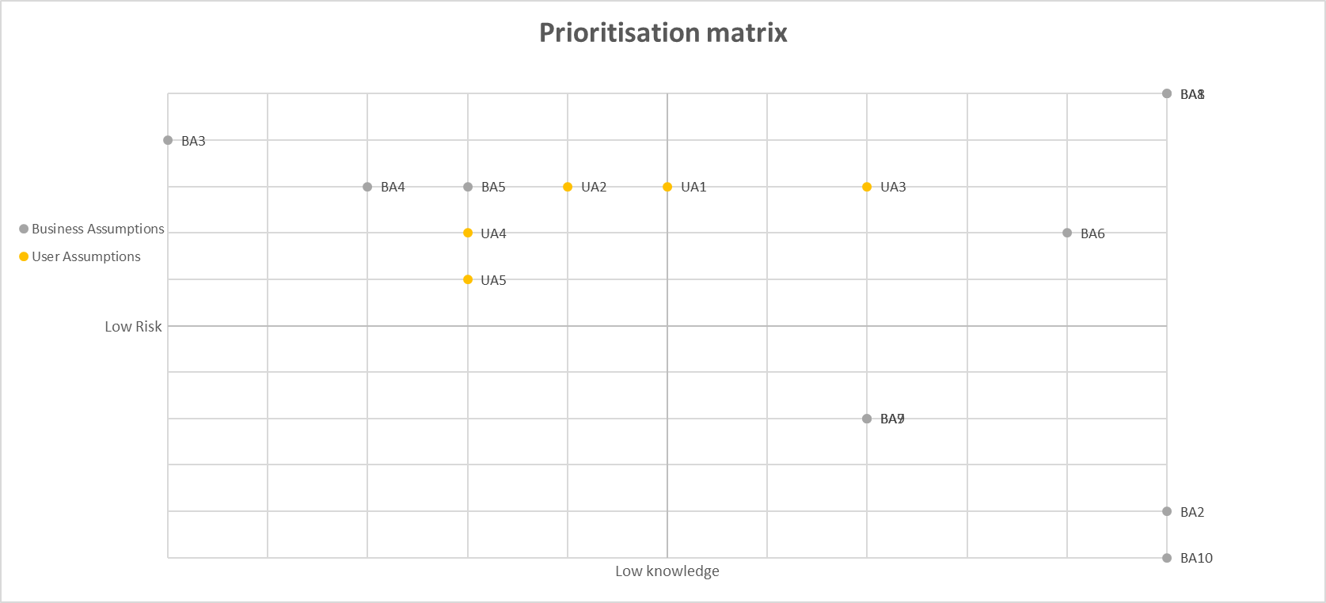

High risk

High knowledge

### Prioritised list of assumptions

From the above list of assumptions and prioritisation matrix, I have picked out several which I believe present the highest risk to the success of my project. This has been determined by examining the consequences of whether my assumptions are wrong and how much knowledge I have around the subject that I have based my assumptions on.

One of my solutions biggest risk of failures comes from the lack of knowledge as to whether the solutions is warranted as well as a lack of knowledge as to whether the application will be able to sufficiently motivate people into taking part in medium intensity fitness. This has been selected as a high-risk assumption as without a general want to participate in the features of the application, customers will move onto applications that better fit their needs.

The largest risk to the success of the application is the lack of knowledge the target audience have of the solution, it is difficult to complete when competition is so fierce and larger competitors are able to advertise using many channels, this assumption has been selected as high risk as if it is proven correct the application will be doomed to fail as it will not have a userbase in which social interaction can take place

The applications novel ideas on how to engage with its target audience seem good in practice, however it is difficult to say whether they will be proven true, this is why the testing of the applications novel ideas is a high requirement as without this proof, the applications key selling point will be unwanted by the userbase.

My customers have a need to be motivated to take part in physical activity and a need to enjoy their free time has been selected as a high priority assumption as this is the general goal of the application, to passively provide motivation to take part in physical activity through a medium that is considered fun by the user base, if this proves to be false the application is doomed to fail

## Hypotheses

### Hypothesis one

I believe my target audience would make use of an application that aims to produce an enjoyable experience but that offers them the opportunity to gain an in-game rewards if they complete a fitness based challenge. I shall be able to test this by producing a prototype application which combines the above elements, which I can then use to test with members of the target demographic

### Hypothesis two

I believe one of the biggest risks to the success of this project is a lack of knowledge of whether my target audience want an application that aims to achieve the gaols laid out in this report, I can produce a paper prototype that will allow for a rapid testing session with my user base to conform or invalidate this hypothesis.

# Appendix D – Paper prototype design

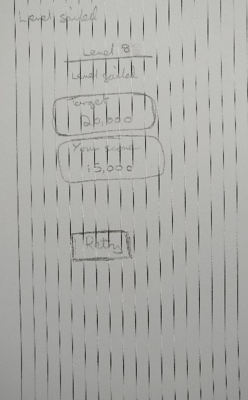

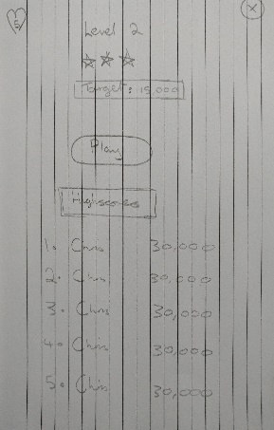

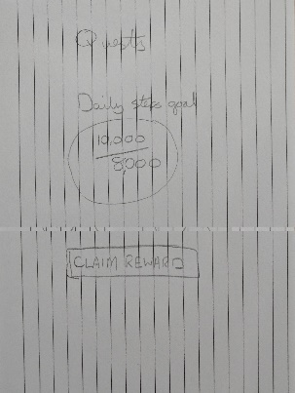

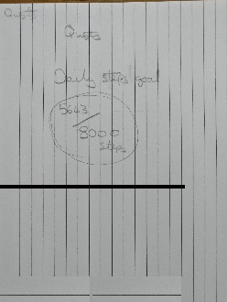

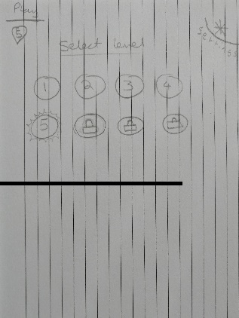

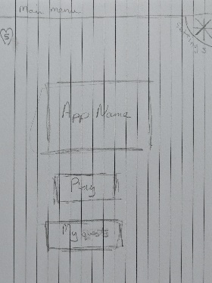

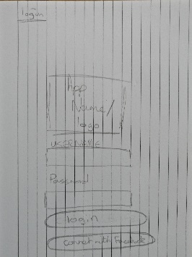

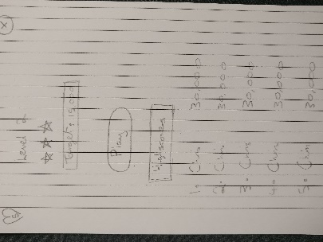

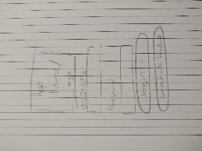

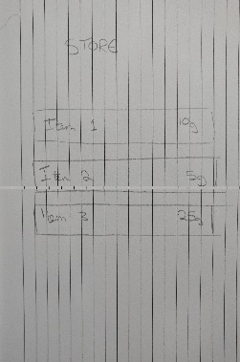

# Appendix E – Usability plan template

Created using the Usability test plan template (Usability test plan template, 2013).

## Overview

This document describes a test plan for conducting a usability test during the development of a mobile fitness game named Sweet Sensation. The goals of usability testing include establishing a baseline of user performance and identifying potential design concerns to be addressed to improve the efficiency, productivity, and end-user satisfaction.

The usability test objectives are:

* To determine design inconsistencies and usability problem areas within the user interface and content areas. Potential sources of error may include:
  + Navigation errors – failure to locate functions, excessive keystrokes to complete a function, failure to follow recommended screen flow.
  + Presentation errors – failure to locate and properly act upon desired information in screens, selection errors due to labelling ambiguities.
* Exercise the application under controlled test conditions with representative users. Data will be used to access whether usability goals regarding an effective, efficient, and well-received user interface have been achieved.
* Establish baseline user performance and user-satisfaction levels of the user interface for future usability evaluations.

The application is targeted at the older generation, users who are likely to want to play games such as Candy Crush. Usability testing will be conducted on who fit this profile (2) and users who do not (4), in total six participants will take part in the study.

## Executive Summary

The goal of this usability analysis is to test whether the system can be used and navigated easily and that functionality within the application makes sense to the user.

Specifically, participants will be tested to see whether they can achieve a high score within the game and then view it on the game leader board, gain an in game reward through the use of the applications fitness elements and whether they can Purchase an in game reward and clearly identify what it was they purchased.

Upon review of this usability test plan, including the draft task scenarios and usability goals for the Sweet Sensation, documented acceptance of the plan is expected.

## Methodology

There will be six participants taking part in a study over two sessions conducted at the premises primarily used for the design of this product and an offsite location, users will interact with the system through the use of a mobile application that will be installed on a number of test devices. The test aims to collect data on user demographic, satisfaction with the system and collect any suggested improvements that could be made.

## Participants

Six participants will take part in this trial, some have been chosen due to their knowledge of the use of similar applications, others due to their knowledge of software design principles and a final subset of users were selected due to them being in the target demographic the application is aimed at. The participants' responsibilities will be to attempt to complete a set of representative task scenarios presented to them in as efficient and timely a manner as possible, and to provide feedback regarding the usability and acceptability of the user interface. The participants will be directed to provide honest opinions regarding the usability of the application, and to participate in post-session subjective questionnaires and debriefing.

## Procedure

Participants will take part in the usability test. Several test mobile phones hosting the application will be used in a typical home environment. The participant’s interaction with the application will be monitored by the facilitator seated in the same location.

The facilitator will brief the participants on the application and instruct the participant that they are evaluating the application, rather than the facilitator evaluating the participant. Participants will sign an informed consent that acknowledges: the participation is voluntary, that participation can cease at any time. The facilitator will ask the participant if they have any questions.

Participants will complete a pretest demographic and background information questionnaire. The facilitator will explain that the amount of time taken to complete the test task will be measured and that exploratory behavior outside the task flow should not occur until after task completion. At the start of each task, the participant will read aloud the task description from the printed copy and begin the task. Time-on-task measurement begins when the participant starts the task.

The facilitator will instruct the participant to ‘think aloud’ so that a verbal record exists of their interaction with the application. The facilitator will observe and log user behavior, user comments, and system actions.

After each task, the participant will answer a post-task questions and elaborate on the task session with the facilitator. After all task scenarios are attempted, the participant will complete the post-test satisfaction questionnaire.

## Roles

The roles involved in a usability test are as follows. An individual may play multiple roles and tests may not require all roles.

### Trainer

* Provide training overview prior to usability testing

### Facilitator

* Provides overview of study to participants
* Defines usability and purpose of usability testing to participants
* Assists in conduct of participant and observer debriefing sessions
* Responds to participant's requests for assistance

### Data Logger

* Records participant’s actions and comments

### Test Participants

* Provides overview of study to participants
* Defines usability and purpose of usability testing to participants
* Assists in conduct of participant and observer debriefing sessions
* Responds to participant's requests for assistance

### Ethics

All persons involved with the usability test are required to adhere to the following ethical guidelines:

* The performance of any test participant must not be individually attributable. Individual participant's name should not be used in reference outside the testing session.
* A description of the participant's performance should not be reported to his or her manager.

## Usability Tasks

The usability tasks were derived from test scenarios developed from the assistance of a subject-matter expert. Due to the short time for which each participant will be available, the tasks are the most common and relatively complex of available functions. The tasks are identical for all participants of a given user role in the study.

The task descriptions below are required to be reviewed by the application owner to ensure that the content, format, and presentation are representative of real use and substantially evaluate the total application. Their **acceptance is to be documented** prior to usability test.

**Task 1 – The user shall navigate through the application and start playing the first available level, upon completion of the level the user will attempt to find their high score**

**Task 2 – The user will attempt to claim the daily award available for reaching a fitness milestone, note for this task the users progress towards the milestone will be set just off from what is required to achieve the award, in order to test how intuitive this is for the user.**

**Task 3 – The user shall attempt to purchase an item from the in-game store with their reward for completing Task 2 above, the user must be able to clearly define what they have purchased, and how this purchase has changed the in game experience.**

## Usability Metrics

Usability metrics refers to user performance measured against specific performance goals necessary to satisfy usability requirements. Scenario completion success rates, error rates, and subjective evaluations will be used. Time-to-completion of scenarios will also be collected.

### Scenario Completion

Each scenario will request, that the participant obtains or inputs specific data that would be used in course of a typical task. The scenario is completed when the participant indicates the scenario's goal has been obtained (whether successfully or unsuccessfully) or the participant requests and receives sufficient guidance as to warrant scoring the scenario as a critical error.

### Critical Errors

Critical errors are deviations at completion from the targets of the scenario. Obtaining or otherwise reporting of the wrong data value due to participant workflow is a critical error. Participants may or may not be aware that the task goal is incorrect or incomplete.

Independent completion of the scenario is a universal goal; help obtained from the other usability test roles is cause to score the scenario a critical error. Critical errors can also be assigned when the participant initiates (or attempts to initiate) and action that will result in the goal state becoming unobtainable. In general, critical errors are unresolved errors during the process of completing the task or errors that produce an incorrect outcome.

### Non-critical Errors

Non-critical errors are errors that are recovered from by the participant or, if not detected, do not result in processing problems or unexpected results. Although non-critical errors can be undetected by the participant, when they are detected they are generally frustrating to the participant.

These errors may be procedural, in which the participant does not complete a scenario in the most optimal means (e.g., excessive steps and keystrokes). These errors may also be errors of confusion (ex., initially selecting the wrong function, using a user-interface control incorrectly such as attempting to edit an un-editable field).

Noncritical errors can always be recovered from during the process of completing the scenario. Exploratory behaviour, such as opening the ski trail while completing a task, will not be coded as a non-critical error.

### Subjective Evaluations

Subjective evaluations regarding ease of use and satisfaction will be collected via questionnaires, and during debriefing at the conclusion of the session. The questionnaires will utilize free-form responses and rating scales.

### Scenario Completion Time (time on task)

The time to complete each scenario, not including subjective evaluation durations, will be recorded.

## Usability Goals

The next section describes the usability goals for Sweet Sensation.

### Completion Rate

Completion rate is the percentage of test participants who successfully complete the task without critical errors. A critical error is defined as an error that results in an incorrect or incomplete outcome. In other words, the completion rate represents the percentage of participants who, when they are finished with the specified task, have an "output" that is correct. Note: If a participant requires assistance in order to achieve a correct output then the task will be scored as a critical error and the overall completion rate for the task will be affected.

**A completion rate of 100% is the goal for each task in this usability test.**

### Error-free rate

Error-free rate is the percentage of test participants who complete the task without any errors (critical **or** non-critical errors). A non-critical error is an error that would not have an impact on the final output of the task but would result in the task being completed less efficiently.

**An error-free rate of 80% is the goal for each task in this usability test.**

### Time on Task (TOT)

The time to complete a scenario is referred to as "time on task". It is measured from the time the person begins the scenario to the time he/she signals completion.

### Subjective Measures

Subjective opinions about specific tasks, time to perform each task, features, and functionality will be surveyed. At the end of the test, participants will rate their satisfaction with the overall system. Combined with the interview/debriefing session, these data are used to assess attitudes of the participants.

## Problem Severity

To prioritize recommendations, a method of problem severity classification will be used in the analysis of the data collected during evaluation activities. The approach treats problem severity as a combination of two factors - the impact of the problem and the frequency of users experiencing the problem during the evaluation.



### Impact

Impact is the ranking of the consequences of the problem by defining the level of impact that the problem has on successful task completion. There are three levels of impact:

* High - prevents the user from completing the task (critical error)
* Moderate - causes user difficulty but the task can be completed (non-critical error)
* Low - minor problems that do not significantly affect the task completion (non-critical error)

### Frequency

Frequency is the percentage of participants who experience the problem when working on a task.

* High: 75% or more of the participants experience the problem
* Moderate: 26% - 74% of participants experience the problem
* Low: 25% or fewer of the participants experience the problem

### Problem Severity Classification

The identified severity for each problem implies a general reward for resolving it, and a general risk for not addressing it, in the current release.

**Severity 1** - High impact problems that often prevent a user from correctly completing a task. They occur in varying frequency and are characteristic of calls to the Help Desk. Reward for resolution is typically exhibited in fewer Help Desk calls and reduced redevelopment costs.

**Severity 2** - Moderate to high frequency problems with moderate to low impact are typical of erroneous actions that the participant recognizes needs to be undone. Reward for resolution is typically exhibited in reduced time on task and decreased training costs.

**Severity 3** - Either moderate problems with low frequency or low problems with moderate frequency; these are minor annoyance problems faced by a number of participants. Reward for resolution is typically exhibited in reduced time on task and increased data integrity.

**Severity 4** - Low impact problems faced by few participants; there is low risk to not resolving these problems. Reward for resolution is typically exhibited in increased user satisfaction.

## Reporting Results

The Usability Test Report will be provided at the conclusion of the usability test. It will consist of a report and/or a presentation of the results; evaluate the usability metrics against the pre-approved goals, subjective evaluations, and specific usability problems and recommendations for resolution. The recommendations will be categorically sized by development to aid in implementation strategy.

# Appendix F – Usability testing consent questionnaires

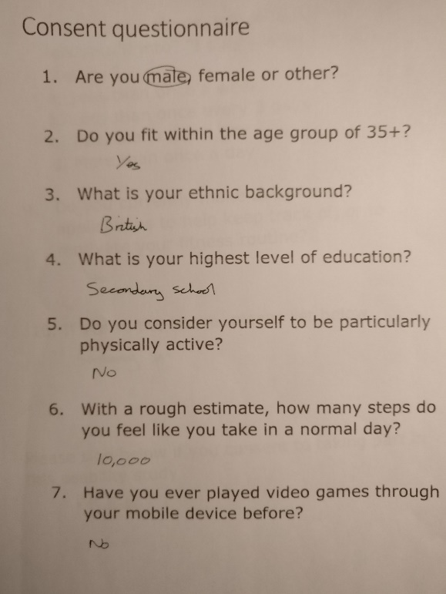

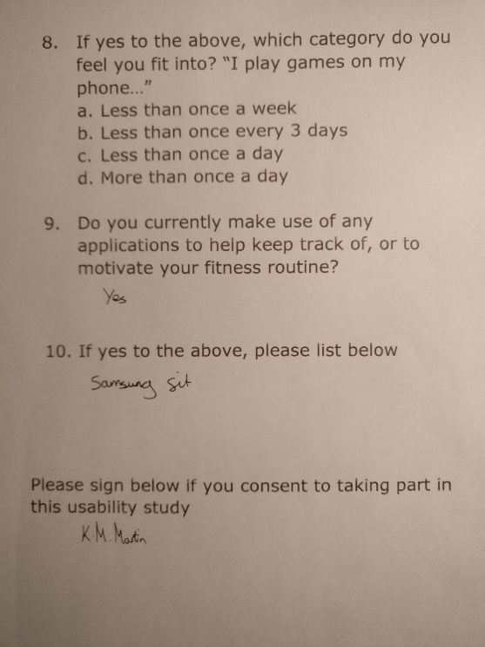

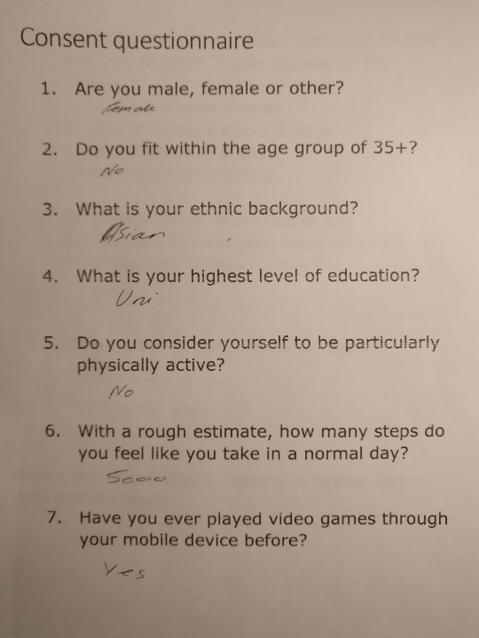

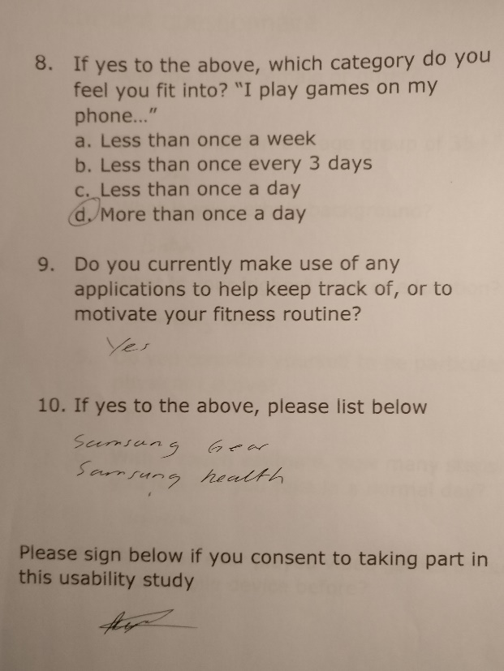

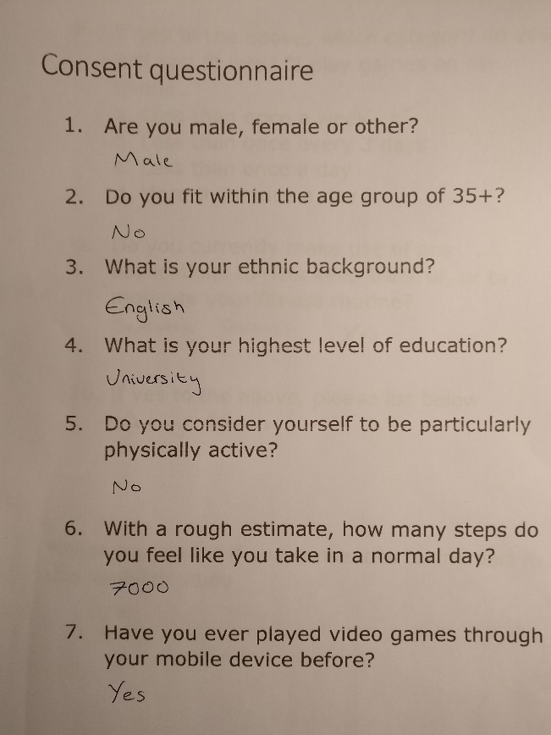

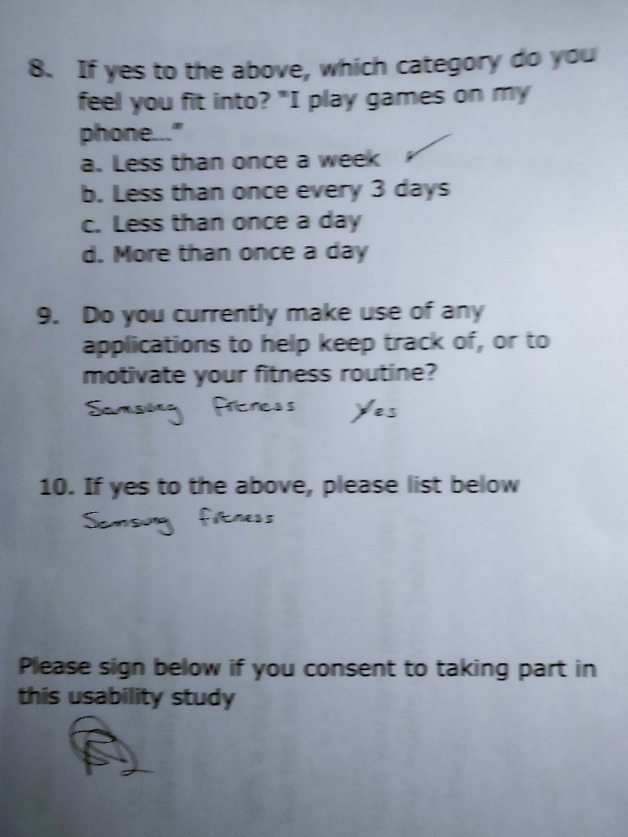

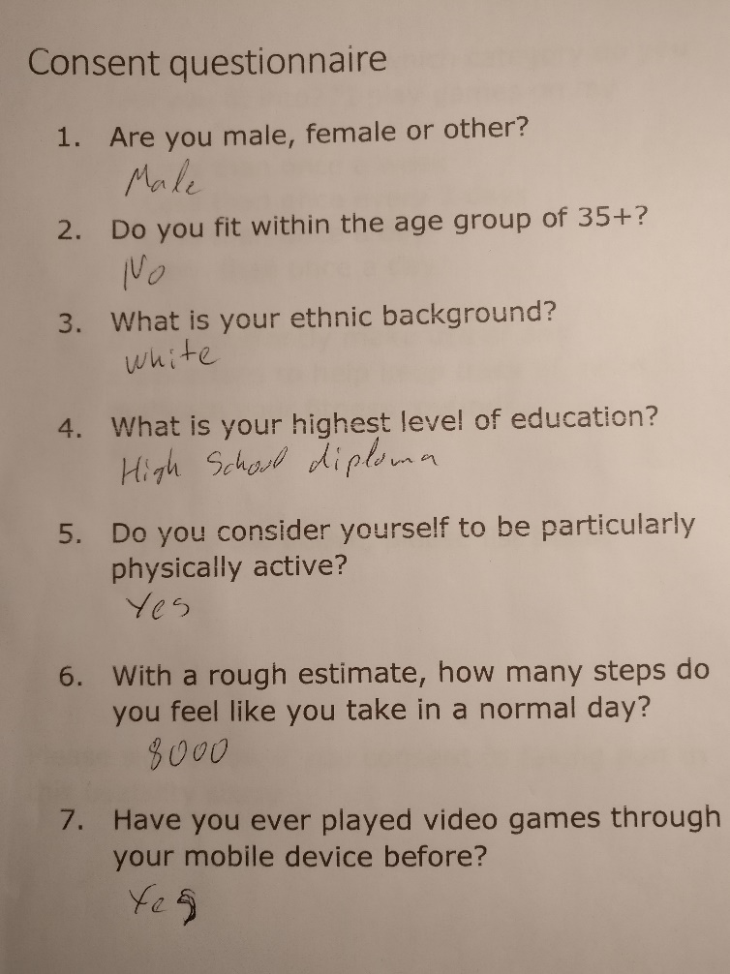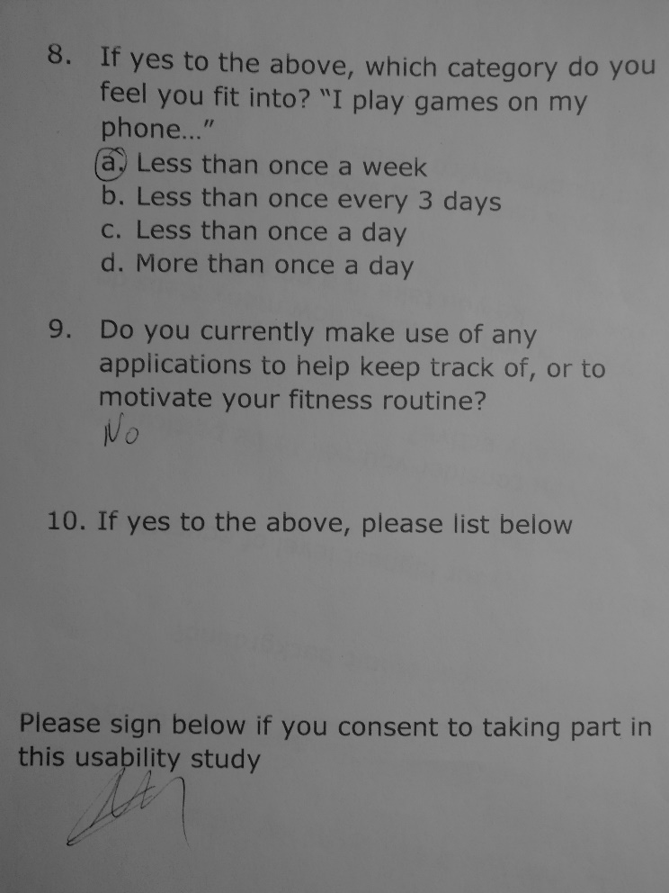

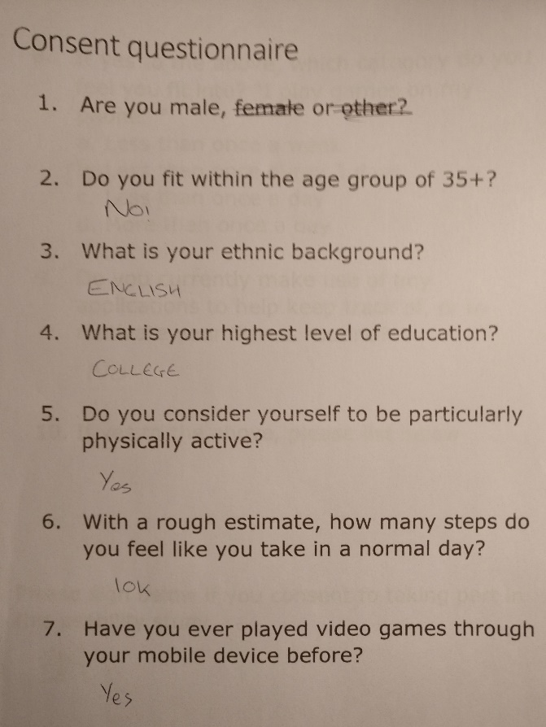

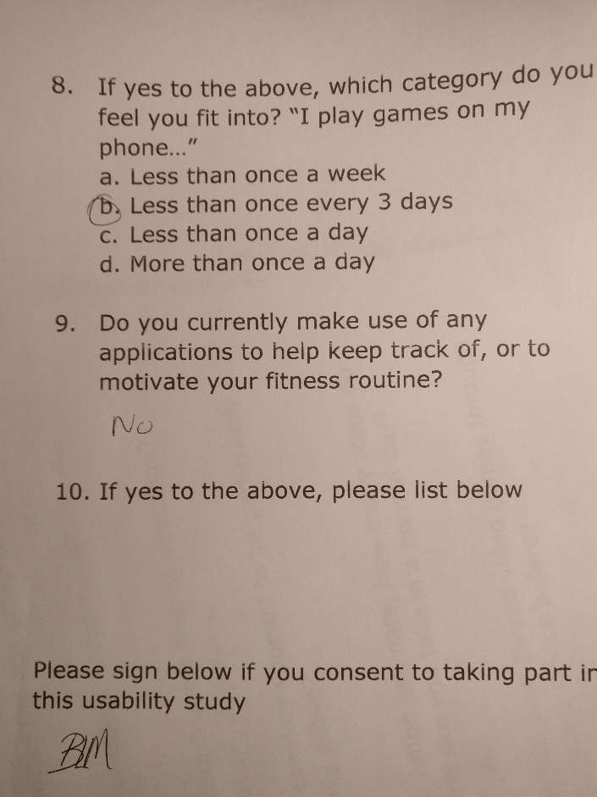

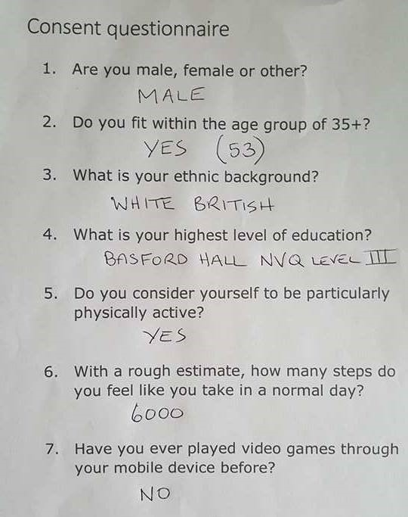

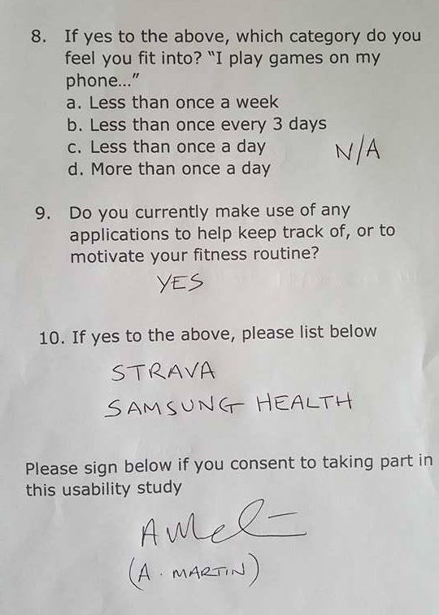

# Appendix G – System Usability Scale results

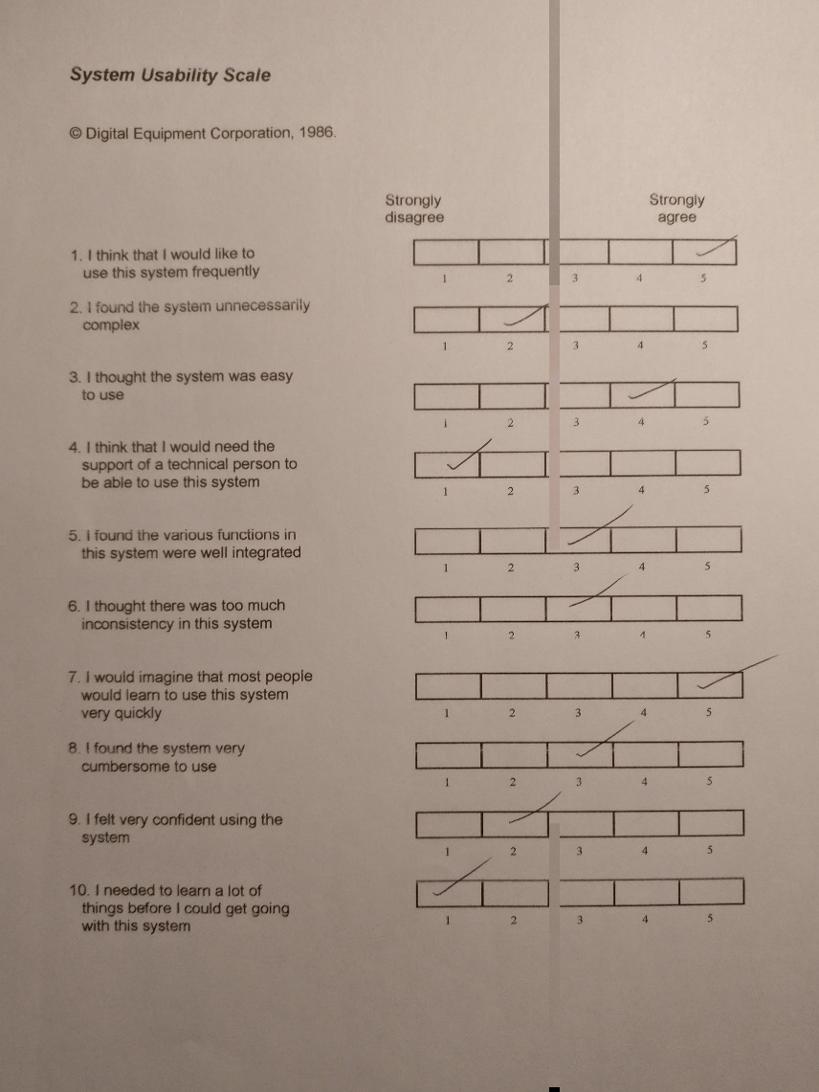

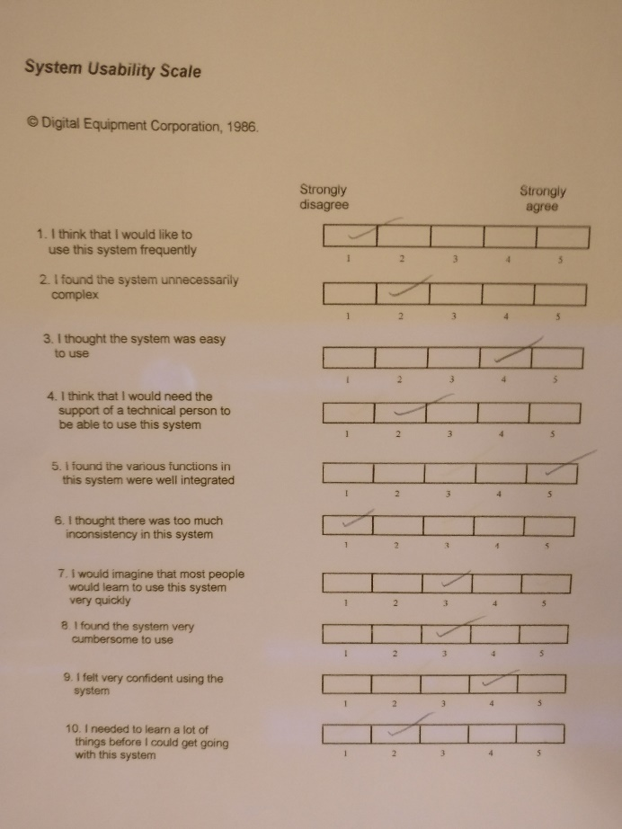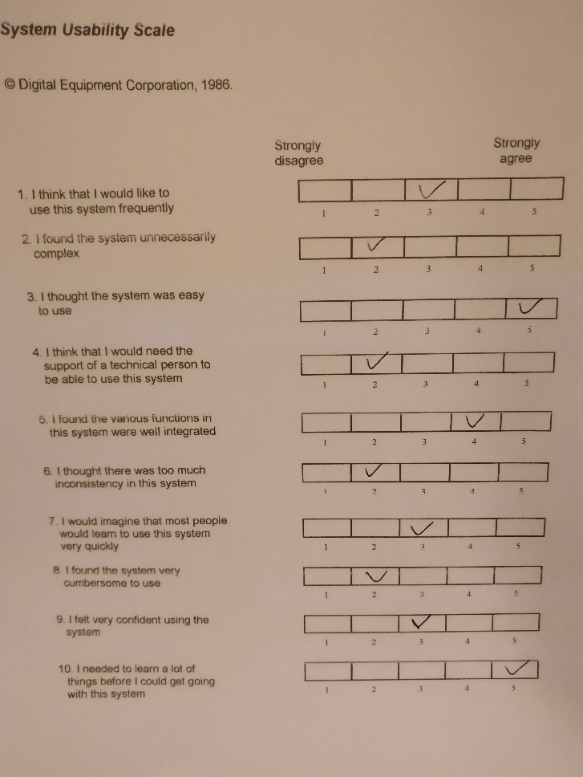

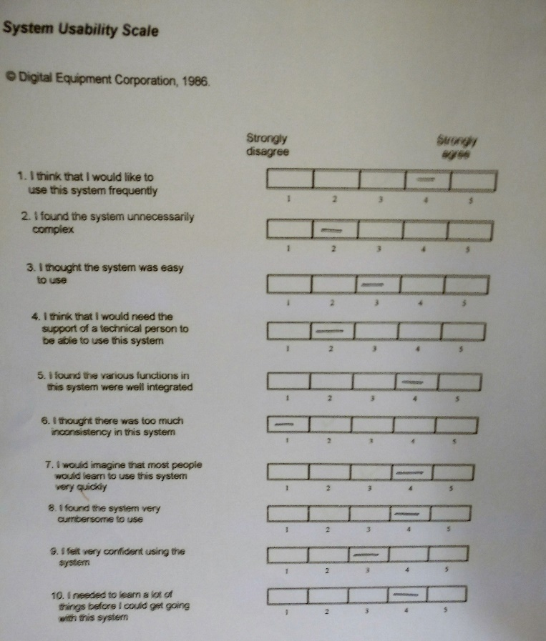

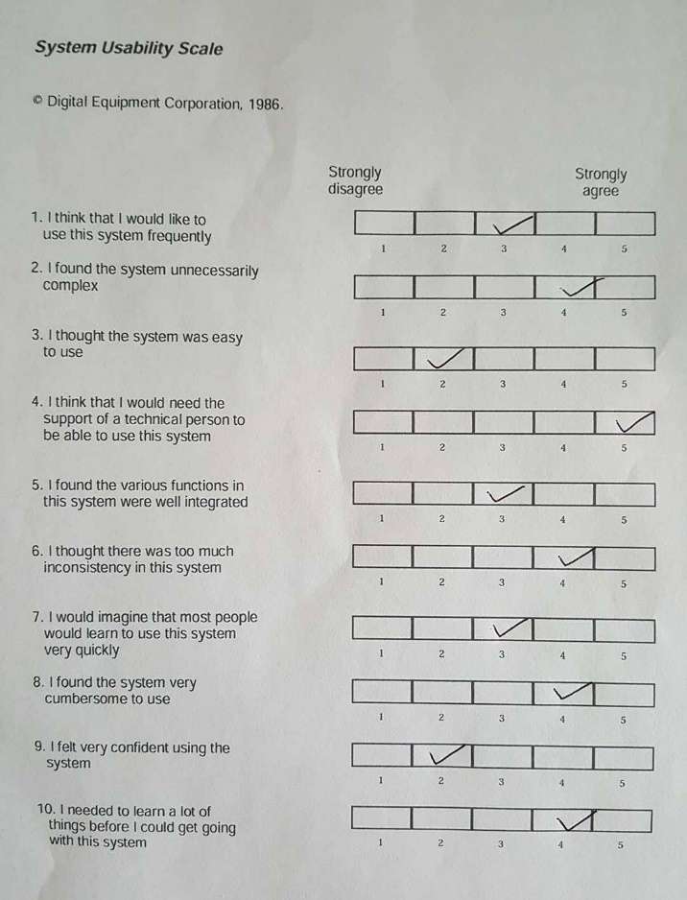

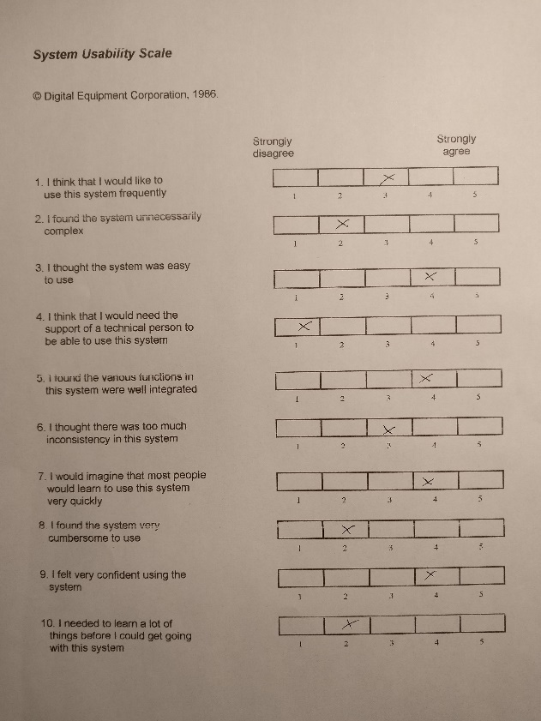

# Appendix H – Full test plan results



# Appendix I – Project Planning Document

## Introduction

The topic of the proposed project is to create a competitive multiplayer mobile game that relies on real world fitness activity to gain an advantage within the game world. The idea is based around the success of mobile fitness applications that have been able to take advantage of improvements and wide scale adoption of health tracking technology and the success of so called freemium games, these are games that are free to play but offer a large in game advantage to players that are willing to spend money on their account. With the switch to in game rewards being given for fitness activity instead of financial. Implications of the project are two-fold; the project has the scope to be able to both fill a gap in the market as currently no other application works in the same way, and to act as a research tool to test whether an application with this kind of incentive could be used to encourage users to undertake more fitness based activities.

## Aims and objectives

### Project aim

To create a mobile based multiplayer game that gives the player character an in-game advantage determined by fitness data captured through their mobile device.

### Project objectives

To fully justify the project, research must be conducted into the state of the current art, a gap in the market must be clearly defined to proceed with project development. A clear competition analysis will be complete by **29/12/2016.**

If the project is deemed justified research will be conducted in several areas, these being;

The psychology behind fitness, specifically the reasons behind why some individuals take part in exercise and why others do not, what methods can be used to encourage a user who do not regularly exercise to do so

The reasons why the most popular mobile fitness applications are at the top of the market, what makes them successful, what do they do that others do not

Analysis of competition in games and fitness and whether common aspects of the two can be used to improve the proposed application

The reasons behind the success of certain types of computer games, specifically what makes them successful, what genre they fall into and would they work as a mobile application

Analysis of multiplayer games and what makes certain types successful and others not.

The reasons behind why the most popular mobile games are popular, with considerations made to the genre, accessibility and overall aesthetic design of the game.

Programming tools and game engines must be researched to determine the most appropriate for the development of the application

Open source API’s should be researched to determine which are the most popular and prevalent and to determine which API or API’s will be most suitable for the development of the project

The findings from the gathered research must then be used as a tool to help develop the application, the research portfolio must be completed by **16/02/2016**.

To finalise the project direction a prototype of the application must be created quickly to allow for any changes in project goals, the most likely change in project goal would be a shift into a project focused fully on the research aspect of whether an application of this mature would be more likely to motivate a user to take part in regular fitness activities. With this in mind a prototype should be developed by **01/01/2016**.

Based on the prototype created usability testing should be undertaken, feedback from this usability testing should be used to improve upon the prototype of the application, this process should occur multiple times over the course of the applications development with the first round of usability being completed by **14/01/2016**.

A mobile application must be created that fills the following criteria;

The application must be a game based around the findings of previously conducted research

The application must offer an in-game reward for the user completing real world fitness activities

The application should be developed to run on a mobile operating system to allow for ease of access and play

The application must make use of fitness data taken from sensors on the user’s mobile device or through the use of open source API’s in order to determine the correct level of in game reward that should be given to the player

The system should be designed to operate online; this is to allow for easier interaction between the active player base.

The application should be designed to be played competitively, this is to increase player engagement and to get the most physical benefit from the application

The application must have undergone a series of user ability tests, feedback from these tests should improve upon the original design

Should these requirements be met the application will be considered complete as far as the scope of this project is concerned, development on the application should be completed by **25/03/2016**.

## Milestones, main tasks and deliverables

## Project scope

The scope of the project is to create a mobile game that makes use of fitness data gathered from health tracking hardware and software located on the user’s mobile device to grant an advantage to the users in game account. The application will be designed operate in a multiplayer setting, with actions of the player potentially having repercussions on other users operating on the game server, this step is designed to improve the social interaction of the game and add an element of competition with the overall goal being a general improvement in engagement of the game.

### Out of scope

Whilst the main goal of the proposed application is wide consumer adoption this is an unlikely outcome when considered in the scope of the project. It is unlikely the application will be made available across multiple platforms although this can be determined by development choice, and it is also an unfeasible goal to state the application will be made available on various application stores such as though available on Android and IOS, this is due to a lack of knowledge on the rules surrounding submission to these application repos and the lack of time available within the project scope to gain the knowledge.

High quality art work is also considered out of scope for this project, unless suitable open source or free use textures and sprites are found online, the lack of experience in this area would require too much time to bring up to a suitable standard.

## Milestones & Main tasks

The following objects represent milestones and main tasks in the final year project, milestones are considered as such in the Gantt chart below with main tasks being made up of several sub tasks in the Gantt chart.

### Project Milestones

Review point 1 & Review point 2 completion

Completed final year project report

Application prototype

Completed application

Project hand in

### Project main tasks

Project Planning Document

Competition analysis

Research portfolio

Usability testing

## Sources of information, resources required

### Resources

**Mobile device with activity tracking hardware or software** – Required to monitor the player’s activity whilst not playing the game the data gathered from this tool is then used to produce the players in game reward.

**A TBD software development kit –** A SDKwill be required to develop the application, based on the findings of the research portfolio an SDK will be selected that best meets the needs of the project.

**Test group –** A test group is required to give feedback on the application, findings from usability tests conducted with the test group will be used to inform on future iterations of the application.

**Web server –** A web server is required to allow for multiplayer activity.

**Database –** Some database will be required to store the players account details and their game progress.

**Development machine –** To produce the application a development machine is required

**Art assets –** As the focus of the project is application development and possible research implications, open source art assets availableonline will be used to implement the visual aspects of the game.

### Sources of information

**Research papers & Books** – Peer reviewed work and published literature will make up the bulk of the background research in this project, this is to maximise the validity of the information used. With the subject matter covered in the project (fitness and gaming) there should be no shortage of books and papers covering these topics.

**Online articles** – To get the most up to date information on player numbers and financial statistics the use of online articles will be crucial, however considerations must be made about the validity of information found online, to overcome this any sources found online will be verified before they are incorporated into the project.

## Project risks

|  |  |  |  |  |  |  |
| --- | --- | --- | --- | --- | --- | --- |
| Risk ID | Risk event description and impact area | Impact rating | Probability rating | Risk score | Risk response description | Trigger |
| Software failure | Software does not function on personal computer | Low | Low | 4 | Attempt to reinstall faulty software, should this fail to fix the problem, work on working computers such as PC’s available on campus | Software error |
| Hardware failure | Development machine is effected by hardware failure stopping work being completed | Low | Low | 4 | Repair broken hardware, whilst this is going on, work on computers provided by the university | Hardware error |
| Networking failure | Networking failure means work cannot be uploaded to the NOW dropbox | High | Low | 2 | Move to a location that has an active network connection, if this is a problem with the universities network hand in a hard copy of the project and contact the university directly for instructions on how to proceed | Hardware error |
| Miss deadline (project imposed) | A project set deadline is missed, throwing time management out of order | Low | High | 3 | Rework the schedule so the incomplete work will still be finished on time for the final hand in | User error |
| Miss deadline (course imposed) | A specific hand in deadline is missed for example handing in a copy of the CMAP | High | Low | 2 | Hand in complete project as soon as possible, follow time schedule closely to reduce the risk of this | User error |
| Scheduling conflict | Other modules take time away from project | Low | High | 3 | Plan work ahead of time to avoid a scheduling risk | User error |
| Lack of experience | Having little experience with software used in project leads to delays in development or poor final product | High | Low | 2 | Start work early to allow for compensations in lack of experience, spend time getting up to speed with software intended for development | User member |
| Loss of data | Specific pieces of project are lost | High | Low | 2 | Create regular backups of any work that is worked on in multiple locations, use source control for development of application | Hardware error |
| Lack of testing | Not enough usability testing is conducted on the application | High | High | 1 | Manage time to allow for sufficient testing, speak to project sponsor if this appears to be a problem | User error |
| Small testing group | Too small a testing group leads to a lack of validity in data | High | High | 1 | Speak with project sponsor | User error |

## Professional, social, ethical and legal issues

### Professional

Within the scope of the project, there are no foreseeable professional issues that require consideration, because of this the project will have a low professional impact.

### Social

The proposed application is an attempt to improve the fitness and lifestyle of its user base, this beneficial social impact needs to be at the forefront of development and be promoted to the users of the system, for this reason the project will have a high social impact.

### Ethical

As with professional issues within the current scope of the project there are no predicted ethical issues related to this project, meaning the ethical impact of this project is low.

### Legal

Depending on the implementation of the application some user data may need to be stored, this requires the project follow laws surrounding data protection. The primary law in the UK for dealing with data protection is the Data Protection act 1998, which states a user’s data must only be used for “limited and specifically stated purposes” and “kept for no longer than is absolutely necessary” (Data protection, 2016). As the legal implications for mishandling a user’s personal data are so high, the legal impact of this project is considered high, to minimise the potential risk the Data Protection act must be studied and adhered to always during the project.

## Gantt chart

